

Full-Stack Home Listing and Rental App for Nigeria.

2025 – Final Report

Author: Mahmud Ribadu Sani

Student ID: M00850923

Supervisor: Siddhaling urolagin

Programme Name: Programme of study bsc information technology

Contents

Full-Stack Home Listing and Rental App for Nigeria. 1

2025 – Final Report 1

Abstract 6

_Toc195440358

Acknowledgement 7

Project Introduction: 7

Full-Stack Home Listing and Rental App for Nigeria. 7

Project Description 7

Aim 8

Objectives 8

Problems Addressed 8

Deliverables 8

Evaluation 9

Work Breakdown Structure 9

Activity List 10

Gantt Chart 10

11

Milestones 11

Resources 11

Literature Review 12

1. Introduction 12

1.2. Full-Stack Web Development in Real Estate Platforms 14

1.3. Impact of Digital Rental Platforms 15

1.4. Comparative Analysis: Nigerian vs. International Property Platforms 16

1.5. Future Trends and Recommendations 17

1.6. Conclusion 17

Requirement Specification 17

Introduction 17

Background and Context 18

Goals and Objectives 19

Stakeholders 20

Authentication & Authorization 21

Agent Workflows 21

Admin Controls 22

Responsive User Interface 22

Notifications and Toasts 22

System Architecture Overview 23

Permission Matrix 24

Database Schema 25

Users Collection 25

Property Collection 29

Risk Analysis 32

Future-Proofing and Extensibility 32

Summary 32

System Design and Implementation 33

Introduction 33

System Architecture Overview 33

Architectural Diagram 34

Requirements Analysis and Modeling 35

High-Level Design 36

Class Diagram 41

Sequence Diagram: Add Property to Wishlist 43

Wireframes and UI Design Decisions 44

Database Design 53

Backend Implementation 55

System Implementation and Testing 57

Frontend Implementation 57

Code Organization Strategy 59

Backend Implementation 60

MongoDB Schema Design 61

Authentication and Authorization 61

User Profile Controller 62

Inquiry and Booking System 62

Security Implementation and Testing 63

Testing Strategy 63

Testing Tools and Techniques 64

Backend API Testing with Postman 64

Areas of Focus 70

Demonstration / Evaluation 73

Introduction 73

Application Walkthrough 73

User Authentication 78

Role-Based Dashboards 83

Key Features Demonstration 86

System Performance Evaluation 88

Key performance indicators: 88

Backend API Performance (Postman Results) 88

Conclusion 90

Overview 90

Critical Evaluation of Process and Outcome 91

Lessons Learned 92

If Starting the Project Again 92

Future Work 93

Final Remarks 94

Appendix 94

Appendix A: Guide to the Material 94

Appendix B: Supervisor Meeting Log 95

Appendix C: Pages 95

Appendix D: References 96

Abstract

The authors developed a complete rental application operating on MERN architectural principles which includes MongoDB, Express.js, React and Node.js in its development. The system delivers a complete web-based service to handle major real estate rental process inefficiencies across Nigeria. The application provides core functional capabilities such as user login authentication along with property management features and validation for agents and features for managing inquiries and wishlists and search filters and user dashboards for client and administrator and agent use. The application leverages RESTful APIs, Redux for state management, and Material UI (MUI) for a sleek and responsive user interface. Developer focus centered first on UX design and system security measures while elevating the platform's capability for modular growth from beginning to end of the development phase.

The initiative studied existing works before determining specific requirements through an organized software development pathway that started with system planning then moved to development as well as testing and assessment phases. The main obstacles lay in maximizing performance for big datasets while setting up secure systems for agent checks and inquiry processing. The future development will center on adding real-time messaging capabilities together with mobile adaptation improvements as well as machine learning applications for property recommendation systems.

Acknowledgement

Without fail I want to thank my supervisor Mr. Siddhaling Urolagin for helping me through this project by providing indispensable guidance together with constant support and encouragement. His guidance and professional input turned into pivotal elements which pushed this work towards its ultimate success.

My deepest thanks belong to His Royal Highness Sani Ahmadu Ahmadu Ribadu who has continuously supported me while imparting his wisdom during my pursuit of potential development. My dear mother Rukaiyatu Sani Ribadu has shown endless gratitude through prayers and sacrifices which complemented her powerful support for my execution.

A sincere acknowledgement must be made to Musa Sani Ribadu and Suleiman Sani Ribadu who provided motivating support throughout the creation of this project. Their supportive words kept me focused throughout my development experience along with keeping me committed to reaching my goals.

The accomplishment of this work became attainable because of the abundant love and wisdom with which the mentioned individuals guided me. I am truly grateful.

Project Introduction:

Full-Stack Home Listing and Rental App for Nigeria.

## Project Description

Housing and rental challenges in Nigeria have long been a significant concern for both landlords and tenants. The process of finding, listing, and renting properties is often inefficient, unorganized, and prone to fraudulent activities. This project aims to develop a full-stack web application that provides a secure and seamless platform for property listings, searches, and rental transactions.

The platform will feature a robust user authentication system, property listing functionalities, search and filter options, a secure payment gateway, and an admin dashboard for system management. It will cater to landlords, real estate agents, and prospective tenants, improving accessibility and reducing transaction inefficiencies.

Aim

To develop an interactive, secure, and scalable full-stack web platform using the MERN stack that streamlines the process of listing and renting homes in Nigeria, mitigating inefficiencies and reducing fraudulent activities.

Objectives

* Develop an intuitive and user-friendly front-end interface using React.js.
* Build a robust backend using Node.js, Express.js, and MongoDB for managing users, properties, and transactions.
* Implement advanced search and filtering functionalities for easy property discovery.
* Integrate secure payment processing for rental transactions.
* Implement an admin dashboard for managing users and property listings.
* Ensure data security and compliance with regulatory requirements.
* Optimize the platform for performance and scalability.

Problems Addressed

* Lack of a centralized digital platform for home rentals in Nigeria.
* Difficulties in verifying rental properties and landlords.
* High risks of rental scams and fraudulent transactions.
* Poor user experience in existing listing platforms.
* Inefficient and time-consuming rental search process.

Deliverables

* Fully functional full-stack web application.
* Secure user authentication and authorization system.
* Property listing and management dashboard.
* Search and filtering features for easy property discovery.
* Integrated payment gateway for secure transactions.
* Admin dashboard for platform management.
* Deployment of the application to a cloud platform.
* Project documentation and user manual.

Evaluation

The project will be evaluated based on:

* Functionality: Ensuring all features work as intended.
* Usability: Conducting user testing to assess ease of navigation.
* Security: Implementing industry-standard security measures.
* Performance: Evaluating system speed, reliability, and scalability.
* Compliance: Adhering to industry standards and regulatory guidelines.

Work Breakdown Structure

1. Requirement Analysis and Planning
   * Researching industry trends and user needs
   * Defining system requirements and scope
   * Creating project timelines and milestones
2. UI/UX Design
   * Wireframing and prototyping using Figma
   * Designing responsive interfaces
   * User experience testing
3. Backend Development
   * Setting up Node.js and Express.js framework
   * Implementing user authentication and authorization with JWT
   * Developing property listing and transaction management
   * Setting up MongoDB database and schemas
4. Frontend Development
   * Designing and implementing React.js components
   * Integrating frontend with backend API
   * Ensuring responsiveness and user accessibility
5. Payment Gateway Implementation
   * Researching and selecting a payment gateway (e.g., Stripe, Paystack)
   * Implementing secure payment processing
   * Testing transaction flow and security compliance
6. Testing and Debugging
   * Conducting unit and integration testing
   * Identifying and fixing bugs
   * Running performance and security tests
7. Deployment and Documentation
   * Deploying to a cloud platform (AWS/GCP/Vercel)
   * Writing user manuals and technical documentation
   * Conducting final project review

Activity List

|  |  |  |
| --- | --- | --- |
| **Activity** | **Dependency** | **Duration** |
| Project Proposal | - | 7 days |
| UI/UX Design | Proposal | 14 days |
| Backend Development | UI/UX | 20 days |
| Frontend Development | Backend | 15 days |
| Payment Gateway Integration | Backend | 10 days |
| Testing and Debugging | Development | 10 days |
| Deployment | Testing | 7 days |
| Documentation | All | 5 days |

Gantt Chart

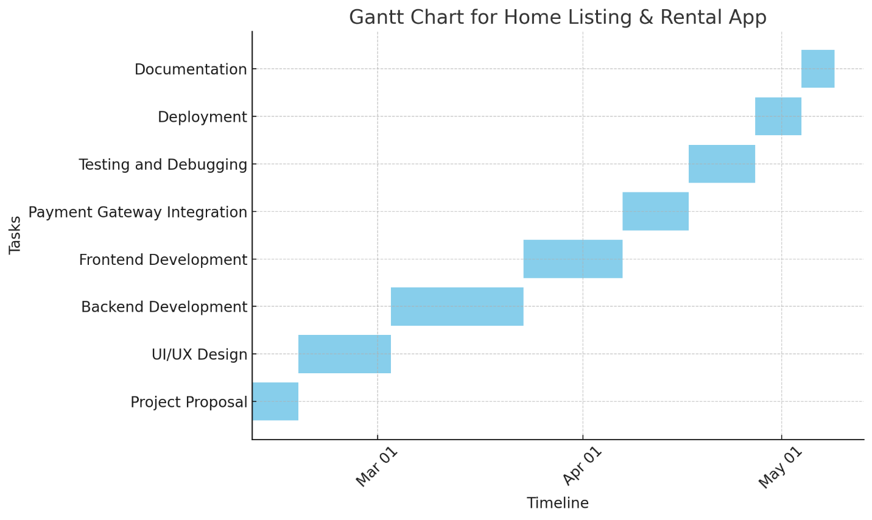

Milestones

1. Completion of UI/UX design.
2. Backend API development completion.
3. Frontend and backend integration.
4. Deployment of MVP version.
5. Final testing and launch.

Resources

* Development Tools: Node.js, Express.js, React.js, MongoDB, Stripe API
* Hosting: AWS/GCP/Vercel
* Testing Tools: Postman, Jest, Cypress
* Documentation: Markdown, Swagger
* Other Tools: Figma for wireframing, Draw.io for Gantt chart and WBS

Literature Review

## 1. Introduction

Property listing along with renting and fraud prevention have remained problematic in the Nigerian real estate sector because of the absence of trustworthy centralized digital platforms (Oluwunmi et al., 2020). Physical house visits together with agent dependency and hand-written documentation procedures in property transactions create numerous inefficiencies and delays while exposing deals to greater fraud risks (Adewale & Jimoh, 2019). The Nigerian housing market maintains limited digital adoption for market transformation which produces fragmented rental procedures across the market (Okonkwo et al., 2021).

1.1.1 Real Estate Digitalization: Global and Nigerian Perspectives

Real estate markets across the world experienced major digital changes to introduce smooth property transactions through technological advancements. There is an industry revolution that occurred through digital platforms like Zillow and Rightmove and Airbnb which implements automated listings with property recommendation using AI features along with secure digital payment systems that benefit from cloud computing along with blockchain and data analytics technologies (Lindqvist, 2019). The platforms deliver better efficiency together with improved user trust through automated system of verifications coupled with digital contracts alongside real-time property status monitoring.

1.1.2. An Introduction to the Housing Rental Sector in Nigeria

Nigeria arrives among the top countries globally regarding urban development because of fast population expansion and migration from rural to urban areas (Olayiwola 2021). Rental properties have gained substantial demand throughout major urban centers in Nigeria including Lagos, Abuja, Port Harcourt and Kano. Nonetheless the ongoing housing shortage which exceeds 22 million units stimulates affordability problems in the nation (Federal Mortgage Bank of Nigeria, 2021).

|  |  |
| --- | --- |
| City | Average Annual Rent Increase (2018-2023) |
| Lagos | 100% |
| Abuja | 85% |
| Portharcourt | 75% |
| Kano | 60% |

Challenges in the Nigerian Rental Market

1.1.3 Fraudulent Transactions

The rental market in Nigeria faces substantial problems because of fraudulent activities. Fake real estate listings as well as unauthorized agents trick renters into financial losses (Ezeokoli et al., 2021). Implementing Blockchain technology in property verification processes according to research improves transparency and trust in the system process and use (Olawale et al., 2022).

1.1.4 Lack of Centralized Platforms

Rental services exist in various remote locations which prevents tenants from accessing verified property listings easily. The property platforms operating in Nigeria fall short of Western standards since they lack unified practices and incomplete property database information (Onibokun & Kumuyi, 2020).

1.1.5 Payment Security and Trust

Online rental payments remain problematic for tenants because they worry about security and lack of enforcement of lease agreements (Uche & Umeokafor, 2019). Implementing of secure payment gateways such as Paystack and Flutterwave functions to boost confidence in transaction.

1.1.6 High Rental Costs and Affordability Issues

Customers face tremendous difficulty in affording their rental housing. Rent prices in Lagos surged above 100% throughout the last five years because of rising demand together with increasing inflation rates (Ajayi, 2022). Many landlords impose a requirement for tenants to pay rent for a period of one to two years upfront which eliminates housing opportunities for several prospective tenants (Eze, 2021).

## 1.2. Full-Stack Web Development in Real Estate Platforms

Web application development encountered a breakthrough through the MERN stack (MongoDB, Express.js, React.js, Node.js) which brings an advantage of scalable development alongside enhanced speed and maintainable outcomes (Gupta & Sharma, 2021). Real estate platforms achieve success by implementing solid authentication protocols together with bulletproof API interfaces and deployment capabilities for cloud infrastructure (Foster et al., 2020).

1.2.1 Backend Development and Data Security

Sensitively handled data by real estate platforms requires both role-based access control (RBAC) and encryption methods according to Singh & Kumar (2019). Through Node.js and Express.js developers gain access to secure databases which let them manage and fetch property data efficiently (Wang et al., 2021).

1.2.2 Frontend Usability and User Experience

A digital rental platform requires high usability because this factor determines how users will adopt the platform. The research demonstrates that responsive design alongside intuitive search filters together with interactive property maps leads to higher user engagement (Brown et al., 2020). By using React.js developers can create components with better maintainability and performance capabilities (Dutta & Kundu, 2021).

1.2.3 Emergence of Digital Solutions in the Rental Market

Online platforms now transform the Nigerian real estate market through improved access systems which also deliver better security features while creating transparent rental transaction processes (Olowookere, 2022). The real estate sector is experiencing changes through several leading platforms *which include:*

|  |  |
| --- | --- |
| Platform | Key Features |
| Nigeria Property Center | Extensive properties database, search and filter |
| RentSmallSmall | Monthly rents payment, screening of tenant |
| Spleet | Digital lease agreements, rent automation |
| HutBay | AI driven property recommendation |

## **1.3. Impact of Digital Rental Platforms**

**1.3.1 Increased Transparency and Security**

**Digital platforms act as verified properties listing sources that reduce the occurrence of rental frauds (Oseni 2022). According to a survey by Balogun (2021) a majority of 78 percent of digital rental platform users in Nigeria had more trust in online search platforms than traditional real estate agents.**

**1.3.2 Improved Efficiency in Property Search and Transactions**

**Users can utilize search filters on PropertyPro and Hutbay to find properties based on location, price and amenities through the platforms (Ibrahim & Lawal, 2021). Digital lease agreements both decrease document preparation requirements and decrease chances of disagreements between parties.**

**1.3.3 Accessibility and Affordability**

**Low-income earners are now able to find rental properties affordable through flexible rent payment solutions that RentSmallSmall offers (Alade 2021). Rental accessibility rates in Lagos have grown by 35% during the previous three years according to information from Afolayan (2022).**

**1.3.4 Payment Gateway Integration in Property Rental Platforms**

**The increase in secure escrow-based payments through fintech innovations makes online rental payments more prevalent (Adegbite & Akinyemi, 2022). An integration of Stripe, Paystack or Flutterwave APIs within platforms allows for secure money transactions which establishes trust between property owners and renters.**

## 1.4. Comparative Analysis: Nigerian vs. International Property Platforms

Digital rental platforms Zillow and Rightmove operate in the United States and United Kingdom through their offerings of data analytics and AI-powered property recommendations (Smith & Johnson, 2021). The platforms use blockchain technology together with transaction security infrastructure (Brown, 2022). The digital rental sector of Nigeria can benefit from implementing established strategies that enhance its transparency alongside security measures.

**1.4.1 User Trust and Verification Methods**

The usage of AI-based fraud prevention systems on Western property platforms helps to validate property listings while preventing fraudulent activities (Huang & Chen, 2018). The verification process on Nigerian platforms depends on manual inspections yet this creates extra time requirements as well as potential human errors according to Balogun et al. (2022).

**1.4.2 Search Optimization and Data Analytics**

Real estate platforms use machine learning models which apply user behavioral patterns to suggest properties to their customers (Zhang et al., 2021). No personalization features exist on Nigerian platforms because they lack sufficient data analytics systems (Obinna et al., 2022).

**1.4.3 Regulatory Frameworks**

Digital property transaction regulations exist in both UK and US jurisdictions (Lawrence 2020). The absence of rigorous online rental laws in Nigeria creates inconsistent legal enforcement because the country does not have sufficient safeguards (Okonkwo et al., 2021).

## 1.5. Future Trends and Recommendations

Digital real estate development in Nigeria requires implementation of smart contracts along with AI fraud analytics and regulatory system enhancements (Owolabi & Adekunle, 2022). PWAs function as a solution to expand user accessibility since they effectively support internet connection limitations (Akinpelu et al., 2021).

*These measures will boost digital rental market solutions*

* Establishing government regulations that standardize digital rental deals through legal frameworks helps consumers feel secure (Olawale, 2022).
* The adoption of digital platforms benefits from users learning about their advantages through public awareness programs which Uche (2022) indicates.
* By merging AI with Blockchain technology both properties can be recommended more effectively while blockchain increases transparency through fraud prevention (Ezekiel, 2022).

## 1.6. Conclusion

In this literature review I have highlighted the gaps in Nigeria’s online rental market and the potential of **full-stack web applications** to mitigate inefficiencies. By incorporating secure payment processing, AI-driven fraud detection, and blockchain-based verification, property transactions in Nigeria can become more transparent and efficient.

****Requirement Specification****

## ****Introduction****

The Requirement Specification document which describes both functional and non-functional system expectations. It functions as a framework that brings developers alongside designers along with stakeholders to confirm system requirements alongside operational boundaries (Sommerville, 2016).

The document presents requirements for developing a MERN stack-based property rental web application which draws inspiration from Magicbricks. The system operates for three main user types: admins, agents and clients.

1. **The Administrator:** handles system maintenance and user authentication systems as well as controls listing content.
2. **The agent's:** features capabilities to advertise properties and modify and handle all rental listings.
3. **Client:** userscan perform search operations and utilize property filters, as well as save their selected properties.

This specification establishes a scalable and secure user-friendly solution because it defines **user needs** alongside **system functionalities**, performance benchmarks, and interaction models that adhere to industry best practices.

## ****Background and Context****

The modern real estate market has experienced digital transformation due to platforms including Magicbricks(India) and Zillow(US) **and **Rightmove (UK),**** that provide new ways to search and lease properties. Some current solutions for this sector demonstrate various difficulties including:

1. Verification gaps: exists because agent verification processes in rental listings fall short which leads to 23% of inaccurate information according to the Real Estate Fraud Report of 2023.
2. Mobile Experiences: According to PropTech Survey (2023) 58% of mobile users express dissatisfaction about poorly interacting interfaces on mobile platforms.
3. Admin Controls: Platform administrators operate without sufficient real-time content moderation tools which affects 67% of administrative control systems.

*The solution fixes these business problems by implementing the following features:*

* Multi-tier verification for agents and property listings
* The system implements adaptive user interface and user experience design based on Material Design 3.0 principles
* Comprehensive admin dashboard with real-time analytics
* Role-based access control with JWT authentication

The user interface and user backend share a unified JavaScript development ecosystem.

The database relies on MongoDB as a NoSQL solution to handle unstructured data for properties.

*The MERN stack received selection for its following strategic characteristics:*

* Full JavaScript compatibility enabling seamless frontend-backend integration
* Document-oriented database (MongoDB) ideal for flexible property schemas
* Vibrant ecosystem with over 1.8 million available packages
* The system demonstrates tested scalability which enables applications supporting userbases of over 10M individuals.

## ****Goals and Objectives****

The application’s **core objectives** are structured to meet the needs of all stakeholders while ensuring **performance, security, and usability**.

|  |  |
| --- | --- |
| **ID** | **Goal Description** |
| **G1** | Enable agents to **list, update, and manage property listings** efficiently. |
| **G2** | Allow clients to **search, filter, and wishlist properties** with ease. |
| **G3** | Provide an **admin interface** for managing users, listings, and analytics. |
| **G4** | Ensure a **responsive, intuitive UI/UX** across all devices. |
| **G5** | Implement **secure authentication (JWT) and role-based access control.** |

These goals align with **industry standards** observed in leading rental platforms (Magicbricks, 2023) while incorporating **modern web development best practices**.

## Stakeholders

Understanding **stakeholder needs** is crucial for system success. The primary stakeholders are:

**Primary Stakeholders**

|  |  |  |
| --- | --- | --- |
| Stakeholder | Role | Needs |
| Clients | End-users seeking rental properties. | Easy navigation, advanced search filters, wishlist functionality. |
| Agents | Professionals listing properties. | Profile management, listing analytics, verification badge. |
| Admins | Platform moderators. | User monitoring, content approval, system analytics. |

Each stakeholder has **distinct requirements**, shaping the system’s **functional and non-functional specifications**.

**Secondary Stakeholders**

1. **Legal Team:** GDPR/CCPA compliance modules
2. **DevOps:** Kubernetes cluster for container orchestration
3. **Marketing:** An integrated analytical system helps marketing organizations with monitoring their campaigns as a result.

## ****Authentication & Authorization****

* **Password Policies**:
  + Minimum 8 characters with complexity requirements
  + BCrypt hashing (work factor 12)
  + Users must register with email and password.
* **Session Management**:
  + JWT-based authentication with role-based access control (RBAC).
  + Refresh tokens (7day expiry, single-use)

## ****Agent Workflows****

1. **Listing Creation**:
   * Title, description, category (apartment, villa, etc.).
   * Price, location (address, city, state).
   * Property details (bedrooms, bathrooms, toilets).
   * Multi-step form with real-time validation
   * Upload up to 4 images
2. **Listing Management**:
   * Update Listing
   * Delete Listing
   * Version history

**Clients Workflows**

* **Search:**
  + Location (city, neighborhood).
  + Price range (min/max).
  + Property type (Buy, Rent, Shortlet etc.).
  + Number of bedrooms/bathrooms.
  + Real-time filtering for instant results.
* **Wishlist Management**
  + Clients can **save properties** to their wishlist.
  + Only authenticated users can add/remove wishlist items.
  + Wishlist is persists across sessions (stored in MongoDB).

### ****Admin Controls****

* **User Management**:
  + View, suspend, or delete users.
  + Moderate listings (approve/reject).
  + Access analytics (user growth, listing trends).
* **Content Moderation**:
  + AI-powered fraud detection
  + Takedown workflows
  + Appeal process handling (Future feature)

### ****Responsive User Interface****

* **Mobile-first design** with **Material-UI (MUI).**
* **Role-specific dashboards** (client, agent, admin).

### ****Notifications and Toasts****

* **Toast messages** for actions (login, logout, register, listing saved, listing update, etc).
* **Real-time feedback** enhances UX.

**Non-Functional Requirements**

The system requires specifications on how it should work.

|  |  |
| --- | --- |
| Requirement | Description |
| Performance | Response time < **200ms** under normal load. |
| Scalability | The system implements MongoDB together with Node.js to provide horizontal scalability to the system. |
| Security | JWT, HTTPS, MongoDB access rules. |
| Usability | The user interface adopts green elements across its design while maintaining an intuitive layout together with straightforward navigation elements, representing Nigeria and Green Energy. |
| Maintainability | Modular React + Redux structure. |
| Accessibility | WAI-ARIA compliance for screen readers. |

## System Architecture Overview

The system follows a three-tier MERN architecture:

CLIENT (React + Redux + MUI)

⇅

SERVER (Node.js + Express)

⇅

DATABASE (MongoDB)

Component Design

[CDN] ←→ [React SPA]

↑↓

[API Gateway] ←→ [Auth Service]

↑↓

[Load Balancer] ←→ [Listing Service] ←→ [MongoDB Sharded Cluster]

REST APIs handle all interactions.

Middleware enforces authentication and authorization.

Data Flow

1. Search Request:
   * Client → API Gateway → Elasticsearch → MongoDB
   * Response time: <800ms (95th percentile)
2. Listing Approval:
   * Admin → Moderation Service → MongoDB
   * Notification → Agent Email/SMS
3. Fetching Data

* Through the GET /properties request the client starts the interaction with the Server.
* Server processes request, queries MongoDB.
* The JSON response moves back to the client from the server.
* The application secures admin routes through middleware protection.

## Permission Matrix

Protected Routes

|  |  |  |  |
| --- | --- | --- | --- |
| **Endpoint** | **Client** | **Agent** | **Admin** |
| POST /listings | ❌ | ✅ (After email verification) | ❌ |
| PUT /listings/:id | ❌ | ✅ (Own listings only) | ✅ |
| DELETE /users | ❌ | ❌ | ✅ |
| Register/Login | ✅ | ✅ | ✅ |
| View Listings | ✅ | ✅ | ✅ |
| Add Listings | ❌ | ✅ | ❌ |
| Wishlist Property | ✅ | ❌ | ❌ |
| Manage Listings | ❌ | ✅ | ✅ |
| View Dashboard | ✅ | ✅ | ✅ |
| Admin Panel Access | ❌ | ❌ | ✅ |

## ****Database Schema****

### ****Users Collection****

import mongoose from "mongoose";

const UserSchema = new mongoose.Schema(

  {

    firstName: { type: String, required: true, trim: true },

    lastName: { type: String, required: true, trim: true },

    email: {

      type: String,

      required: true,

      unique: true,

      match: [/^\w+([.-]?\w+)*@\w+([.-]?\w+)*(\.\w{2,3})+$/, 'Please fill a valid email address']

    },

    password: { type: String, required: true, minlength: 6 },

    phone: {

      type: String,

      required: true,

      validate: {

        validator: function(v) {

          return /^(\+234|0)?[0-9]{10}$/.test(v);

        },

        message: props => `${props.value} is not a valid phone number!`

      }

    },

    role: {

      type: String,

      enum: ["client", "agent", "admin"],

      required: true,

      default: "client"

    },

    profileImage: { type: String },

    isVerified: { type: Boolean, default: false },

    isActive: { type: Boolean, default: true },

    savedListings: [{

      type: mongoose.Schema.Types.ObjectId,

      ref: "Property",

      default: []

    }],

    activeListings: [{

      type: mongoose.Schema.Types.ObjectId,

      ref: "Property",

      default: []

    }],

    agentDetails: {

*// Basic Info*

      companyName: {

        type: String,

        required: function() { return *this*.role === 'agent'; }

      },

      title: {

        type: String,

        default: "Real Estate Agent"

      },

      bio: {

        type: String,

        maxlength: 500,

        default: ""

      },

*// Professional Credentials*

      licenseNumber: {

        type: String,

        required: function() { return *this*.role === 'agent'; }

      },

*// Contact Info*

      officeAddress: { type: String, default: "" },

      officeHours: {

        type: String,

        default: "Mon-Fri 9am-5pm"

      },

*// Market Specialization*

      specialties: {

        type: [String],

        enum: [

          'Residential',

          'Commercial',

          'Luxury',

          'Rentals',

          'Land',

          'International',

          'Senior Housing',

        ],

        default: []

      },

      serviceAreas: {

        type: [String],

        default: []

      },

      languages: {

        type: [String],

        enum: [

          'English',

          'Spanish',

          'French',

          'Hausa',

          'Yoruba',

          'Igbo',

          'Russian',

        ],

        default: ['English']

      },

*// Performance Metrics*

      teamSize: {

        type: Number,

        min: 1,

        default: 1

      },

*// Social Proof*

      awards: {

        type: [String],

        default: []

      }

    },

*// Subscription Data*

    subscription: {

      type: mongoose.Schema.Types.ObjectId,

      ref: "Subscription",

      default: null

    },

    subscriptionExpiresAt: {

      type: Date,

      default: null

    },

*// Listing Limits*

    freeListingsRemaining: {

      type: Number,

      min: 0,

      default: 5

    },

    lastFreeListingReset: {

      type: Date,

      default: null

    },

  },

  {

    timestamps: true,

    toJSON: { virtuals: true },

    toObject: { virtuals: true }

  }

);

*// Virtual for full name*

UserSchema.virtual('fullName').get(function() {

  return `${*this*.firstName} ${*this*.lastName}`;

});

*// Virtual for years in business (calculated from createdAt)*

UserSchema.virtual('yearsInBusiness').get(function() {

  if (!*this*.createdAt) return 1;

  const diffYears = new Date().getFullYear() - *this*.createdAt.getFullYear();

  return Math.max(diffYears, 1); *// Minimum 1 year*

});

*// Indexes for better query performance*

UserSchema.index({ email: 1 });

UserSchema.index({ role: 1 });

UserSchema.index({ 'agentDetails.specialties': 1 });

UserSchema.index({ 'agentDetails.serviceAreas': 1 });

const User = mongoose.model("User", UserSchema);

export default User;

### ****Property Collection****

import mongoose from "mongoose";

const PropertySchema = new mongoose.Schema(

    {

      agent: { type: mongoose.Schema.Types.ObjectId, ref: "User", required: true }, *// Reference to Agent*

      title: { type: String, required: true },

      description: { type: String, required: true },

      category: { type: String, enum: ["rent", "buy", "shortlet"], required: true },

      price: { type: Number, required: true },

      location: {

        city: { type: String, required: true },

        state: { type: String, required: true },

        address: { type: String, required: true },

        longitude: { type: Number },

        latitude: { type: Number },

      },

      bedrooms: { type: Number, required: true },

      bathrooms: { type: Number, required: true },

      toilets: { type: Number, required: true },

      images: [{ type: String, required: true }], *// Array of image URLs (Max: 4)*

      isAvailable: { type: Boolean, default: true },

*// Featured Status (Updated when agent pays for a listing)*

      isFeatured: { type: Boolean, default: false },

      featuredExpiresAt: { type: Date, default: null },

    },

    { timestamps: true }

  );

  const Property = mongoose.model("Property", PropertySchema);

  export default Property;

Inquiry Schema

import mongoose from "mongoose";

const InquirySchema = new mongoose.Schema(

    {

      property: { type: mongoose.Schema.Types.ObjectId, ref: "Property", required: false },

      client: { type: mongoose.Schema.Types.ObjectId, ref: "User", required: true },

      agent: { type: mongoose.Schema.Types.ObjectId, ref: "User", required: true },

      message: { type: String, required: true },

      reply: {

        type: String,

        default: "",

      },

      status: { type: String, enum: ["pending", "replied"], default: "pending" },

    },

    { timestamps: true }

  );

  const Inquiry = mongoose.model("Subscription", InquirySchema);

  export default Inquiry;

User Stories

|  |  |  |  |
| --- | --- | --- | --- |
| **ID** | **As a...** | **I want to...** | **So that I can...** |
| US1 | Client | Search for apartments | Find suitable properties. |
| US2 | Agent | Add new listings | Rent out properties. |
| US3 | Admin | Moderate listings | Ensure platform trust. |

Assumptions and Constraints

* Stable internet required.
* Backend hosted on cloud (Render/Railway).
* Image storage via Cloudinary/local disk.

4.13 System Requirements

|  |  |
| --- | --- |
| **Component** | **Minimum Requirement** |
| OS | Windows 10 / macOS / Linux |
| RAM | 4 GB (8 GB recommended) |
| Browser | Latest Chrome/Firefox |
| Backend | Node.js 18+, Express 4.x |
| Frontend | React 18+, MUI 5 |
| Database | MongoDB Atlas (Cloud) |

## Risk Analysis

|  |  |  |  |
| --- | --- | --- | --- |
| Risk | Probability | Impact | Mitigation |
| Server downtime | Medium | High | Uptime monitoring + backups |
| Data breach | Low | High | Encryption + access controls |
| Low adoption | Medium | Medium | UX testing + marketing |

## Future-Proofing and Extensibility

Future development of the system includes scalability components and potential new features will be implemented.

* In-app chat (Agent ↔ Client).
* Payment gateway integration.
* AI-driven recommendations.
* Mobile app (React Native).

*The system architecture based on MERN can scale effectively (Parsons et al., 2022).*

## Summary

The Requirement Specification contains a detailed description for building a rental platform which combines scalability and security alongside user-friendly features. Applied MERN stack best practices allow the application to deliver superior performance while meeting UX expectations and administrative requirements thus making it a competitive option in digital real estate.

System Design and Implementation

## **Introduction**

The fundamental part of software engineering consists of system design because it creates a bridge that leads from required projects to operational systems. The process analyzes system components through structured techniques to create models and arrange their elements while satisfying functional and non-functional needs (Pressman & Maxim, 2020). The rental application based on MERN stack was designed for Magicbricks-type platforms to establish essential system elements including different user groups (admin, agent, client) and data movement patterns and interface structures and backend system components.

A properly organized system design creates programs that provide scalable architecture alongside functional security capabilities combined with easy usability. Modern modeling implements UML alongside class diagrams and sequence diagrams and wireframes (Fowler, 2004) to reach this objective. Through these tools stakeholders could see a detailed illustration of how the system organized its structure and its component-to-component relationships and user pathways to validate expectations.

The MERN stack proved optimal for building JavaScript full-stack applications since it enables effortless unification of backend and frontend development parts. The combination of MongoDB as a NoSQL database system with Express.js as a backend framework and Node.js for server-side execution produces a robust solution alongside React which delivers dynamic user interfaces.

The developers incorporated system design principles that lead to modular development allowing future maintenance and extension capabilities for long-lasting rental application success. This section provides detailed information about the system development process which includes the implementation approaches alongside the encountered obstacles during the creation phase.

## System Architecture Overview

The rental application utilises three-tier architecture for modular structure and scalability and effective concern division. The system architecture includes three distinguishable sections according to this model.

Presentation Layer: which is the frontend interface utilizes React.js to deliver dynamic user interfaces that help users including administrators, agents, and clients engage effortlessly. Through its components design structure React optimizes both state management and reuse capabilities which results in better performance and superior user experience.

Application Layer: The Node.js and Express.js integration constitutes the Application Layer (Backend) that handles business authentication processes and API routing and business logic operations. The Express middleware defends against unauthorized requests while implementing error management protocols and safety features and enables RESTful API functions to enable front-end and database communication.

Data Layer: MongoDB which operates as a NoSQL database system to manage rental property data through its unstructured format. Through Mongoose ODM's (Object Data Modeling) schema enforcement mechanism the database maintains consistent and whole data records.

The architectural design enables better maintenance alongside scalable operations and enhanced speed because of its ability to handle multiple user requests simultaneously (Kriss, 2020).

## Architectural Diagram

Diagram Description:

A diagram presents the system layers which communicate with one another as follows.

* User Interaction: The backend interacts with user requests which originate from the React.js frontend interface.
* Backend Processing: Express.js handles these requests through backend processing where it enables authentication (JWT) middleware alongside validation as well as execution of business logic.
* Database Operations: The system handles database tasks through MongoDB while Mongoose conducts business logic functions to maintain data structure integrity.

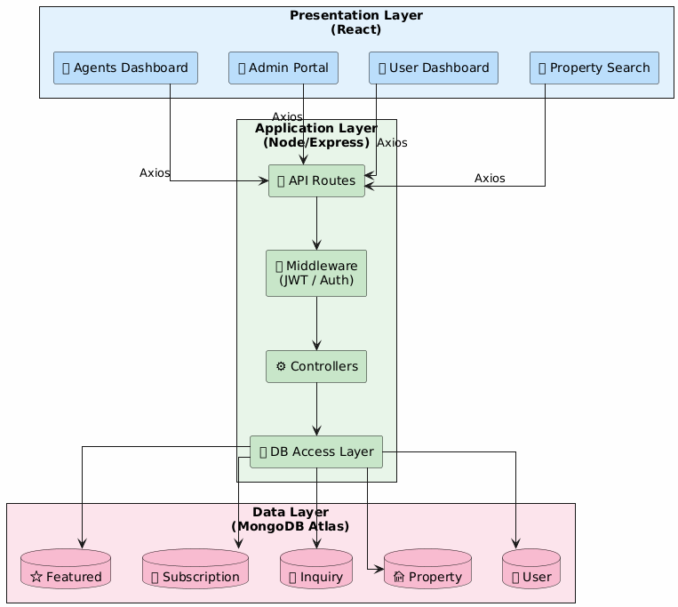

*The illustration for Figure 1 presents the Three-Tier Architecture flow diagram.*

## Requirements Analysis and Modeling

The system development employed Unified Modeling Language (UML) techniques for accurate implementation of functional and non-functional requirements.

1. An Entity-Relationship Diagram (ERD) served to create the database structure and display entity connection relationships such as users together with properties and bookings.
2. The Class Diagram presents abstract system elements including (User, Property, Agent) along with their data interaction points that support object-oriented design patterns.
3. Sequence Diagram interpreted user-system exchanges regarding property booking and admin verification procedures to simplify the process sequence.
4. Wireframes displayed designs for major user interface and user experience screens throughout the application which promoted easy navigation.

The models functioned to maintain stakeholder expectations alignment with the developed system along with reducing implementation ambiguities.

## High-Level Design

Entity-Relationship Diagram (ERD)

Overview

The ER diagram presents both major entities and their attributes together with their relationships which precisely correspond to the MongoDB schemas.

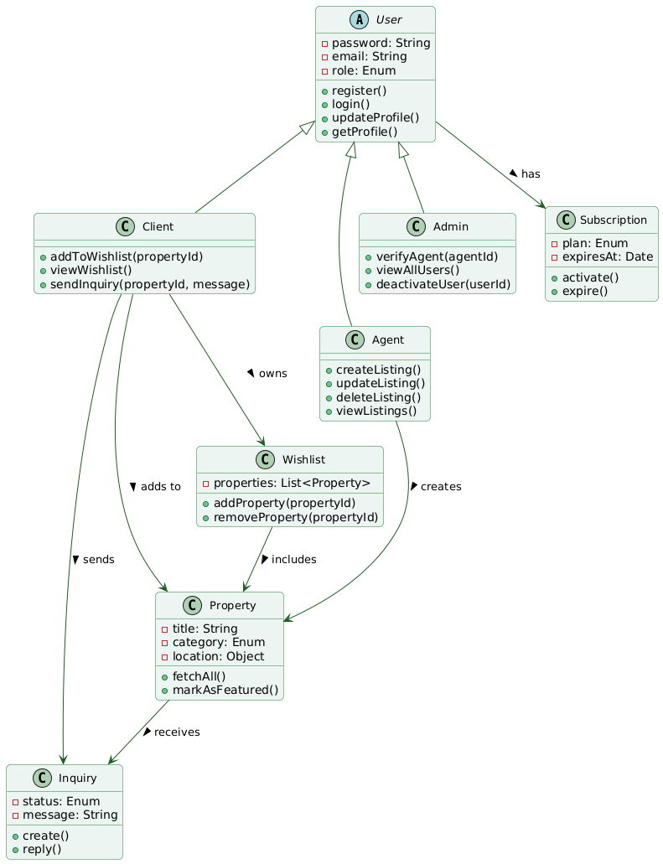

User

*All three user types (Client, Agent and Admin) have representation through this entity.*

Attributes:

* userId (ObjectId, PK)
* firstName, lastName, email, password, phone
* role (Enum: client | agent | admin)
* profileImage, isVerified, isActive
* savedListings[] → References to Property
* activeListings[] → References to Property
* subscription → Reference to Subscription
* subscriptionExpiresAt, freeListingsRemaining, lastFreeListingReset

Agent Details (for agents only):

* companyName, title, bio, licenseNumber
* officeAddress, officeHours
* specialties[], serviceAreas[], languages[]
* teamSize, awards[]

Relationships:

* One-to-many with Property (as agent)
* One-to-many with Inquiry (as client or agent)
* One-to-one with Subscription
* Many-to-many with Property via saved listings

Property

*Represents each property listed by an agent.*

Attributes:

* propertyId (ObjectId, PK)
* title, description, category (Enum: rent | buy | shortlet)
* price, isAvailable, isFeatured, featuredExpiresAt
* location: address, city, state, latitude, longitude
* bedrooms, bathrooms, toilets
* images[] (URLs)
* agentId → Reference to User

Relationships:

* Many-to-one with User (Agent)
* One-to-many with Inquiry
* One-to-one with FeaturedListing
* Many-to-many with User via savedListings

Inquiry

*Represents a message sent by a client to an agent regarding a property.*

Attributes:

* inquiryId (ObjectId, PK)
* propertyId → Reference to Property
* clientId → Reference to User
* agentId → Reference to User
* message, status (Enum: pending | replied)

Relationships:

* Many-to-one with User (client and agent)
* Many-to-one with Property

FeaturedListing

*Represents a paid listing that is highlighted for greater visibility.*

Attributes:

* featuredListingId (ObjectId, PK)
* agentId → Reference to User
* propertyId → Reference to Property
* duration (in days), amount
* status (Enum: active | expired)
* featuredExpiresAt

Relationships:

* One-to-one with Property
* Many-to-one with User (Agent)

Subscription

Represents a subscription plan purchased by an agent.

Attributes:

* subscriptionId (ObjectId, PK)
* agentId → Reference to User
* plan (Enum: free | premium | enterprise)
* duration (Enum: monthly | yearly)
* amount, status, expiresAt
* maxListings, freeFeaturedListings, discountOnFeatured

Relationships:

* One-to-one with User

Wishlist / Saved Listings

*Managed inside the User schema as savedListings[], not a standalone model.*

Representation:

* Many-to-many relationship between User and Property
* Users can add or remove properties from their wishlist (savedListings)

Summary of Relationships

|  |  |  |
| --- | --- | --- |
| **Entity** | **Related To** | **Relationship Type** |
| User | Property | One-to-Many (Agent listings) |
| User | Inquiry | One-to-Many (client & agent) |
| User | Subscription | One-to-One |
| User | Property (Saved) | Many-to-Many |
| Property | FeaturedListing | One-to-One |
| Property | Inquiry | One-to-Many |
| Inquiry | User (Client/Agent) | Many-to-One |
| FeaturedListing | User & Property | Many-to-One |

Description: One-to-many relationship between User and Property (an agent can list many properties), and a many-to-many relationship between Client and Property via Wishlist. This structure optimizes data integrity and user personalization (Elmasri & Navathe, 2015).

## Class Diagram

Classes and Methods:

* User (abstract)

+register()

+login()

+updateProfile()

+getProfile()

* Client *(inherits User)*

+addToWishlist(propertyId)

+viewWishlist()

+sendInquiry(propertyId, message)

* Agent *(inherits User)*

+createListing()

+updateListing()

+deleteListing()

+viewListings()

* Admin *(inherits User)*

+verifyAgent(agentId)

+viewAllUsers()

+deactivateUser(userId)

* Property

+fetchAll()

+markAsFeatured()

* Wishlist

+addProperty(propertyId)

+removeProperty(propertyId)

* Inquiry

+create()

+reply()

* Subscription

+activate()

+expire()



*Figure: Class Diagram*

Description:

A modular and extensible architecture appears in the class diagram. The abstract User superclass utilizes three subclasses to delegate its responsibilities through Client and Agent together with Admin. The design enables maintenance-friendly segregation of behavior by role while it enforces permission restrictions throughout the system. Entity ownership and data flow patterns are supported by the aggregation relationships that link Users with Property entities and Wishlist and Inquiry entities. The OOP design mimics the classic reusability concepts which were explained by Gamma et al. (1995).

## Sequence Diagram: Add Property to Wishlist

Actors:

* Client
* React UI
* API Server (Express + Middleware)
* MongoDB

Flow:

1. When the client selects the wishlist icon from a property page it triggers the process.
2. A POST /api/wishlist/:propertyId operation executes from the React UI.
3. The API Server receives a request which passes through middleware that both verifies JWT authentication while checking that the role equals 'client'.
4. The API server examines the list of properties in the wishlist prior to the current query.
5. The savedListings array located in the User document is updated.
6. API responds with success.
7. The system shows a toast notification with the text "Added to Wishlist!".

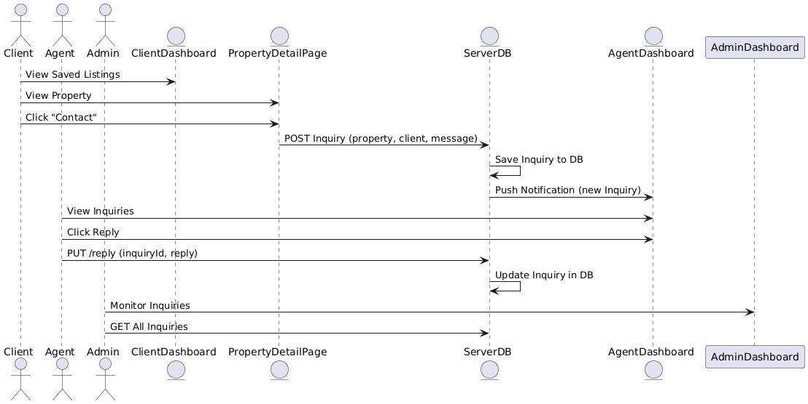

*Figure: Sequence Diagram Rental-App-MERN*

Description: This sequence demonstrates the entire process to add properties to client wishlist functionality. The API implementation verifies the token alongside roles to allow secure property addition through only authorized clients. Each interaction showcases response timing and data handling across layers. The system enables traceability of activities through its design principles which follow Booch, Rumbaugh & Jacobson (2005).

## Wireframes and UI Design Decisions

We used Figma to generate wireframes which allowed us to demonstrate the main user interfaces of the rental app. Key screens include:

* Homepage
* Property Listing Page
* Property Detail Page
* Agent Dashboard
* Admin Portal
* User Profile Page
* Wishlist Page
* Login
* Register

Wireframing helps to quickly make multiple improvements while collecting feedback from each other before beginning development work. The design system utilized Material UI (MUI) design concepts alongside current UX guidelines.

Design Considerations.

Responsiveness:

The interfaces used grid systems along with flexible containers to achieve flawless usability between different devices. The design framework adjusts its layout automatically between small mobile devices and full-screen computer display screens by applying mobile-first design guidelines (Marcotte, 2010).

Visual Hierarchy:

Users engaged with important actions such as listing posting and contact initiation as well as wishlist addition through design elements which included elevated buttons and iconography alongside purposeful whitespace areas. By following Fitts's Law the design system reduces the mental workload of users as explained by Norman (2013).

Color Scheme:

The platform used green color branding to send signals about trust together with stability and growth which real estate websites require as core attributes. Active and call-to-action buttons received corresponding accent shades to draw viewers while the application's content maintained its clear appearance through the use of soft neutrals. User confidence and engagement increase when design elements use the color green because green produces a calming effect according to Lidwell, Holden, and Butler (2010).

Accessibility:

The implementation of ARIA (Accessible Rich Internet Applications) attributes together with semantic HTML elements served to improve screen reader capabilities. All platform elements satisfy WCAG 2.1 criterion for visual contrast so users with vision disabilities can read the content. The navigability of the keyboard was checked against all interactive components.

Consistency:

The MUI library provided a component-based design system that established uniform functioning along with design consistency. The modular framework improved system maintainability because it enabled enhanced usability across the system.

User Feedback Integration:

A group conducted heuristic evaluations along with usability tests on the design wireframes at an early stage. The analysis and rearrangement of filters and icons for the design alongside validation improvements came from evaluations by 5 target user participants.

"A good UI is invisible. Users can concentrate on reaching their goal by using interaction elements designed to maintain their focus on the set objective rather than interface controls. — Nielsen (2001)

1. Homepage Wireframe

This wireframe outlines the structure of the landing page, which includes a hero section with search capability, featured listings, and navigation elements.

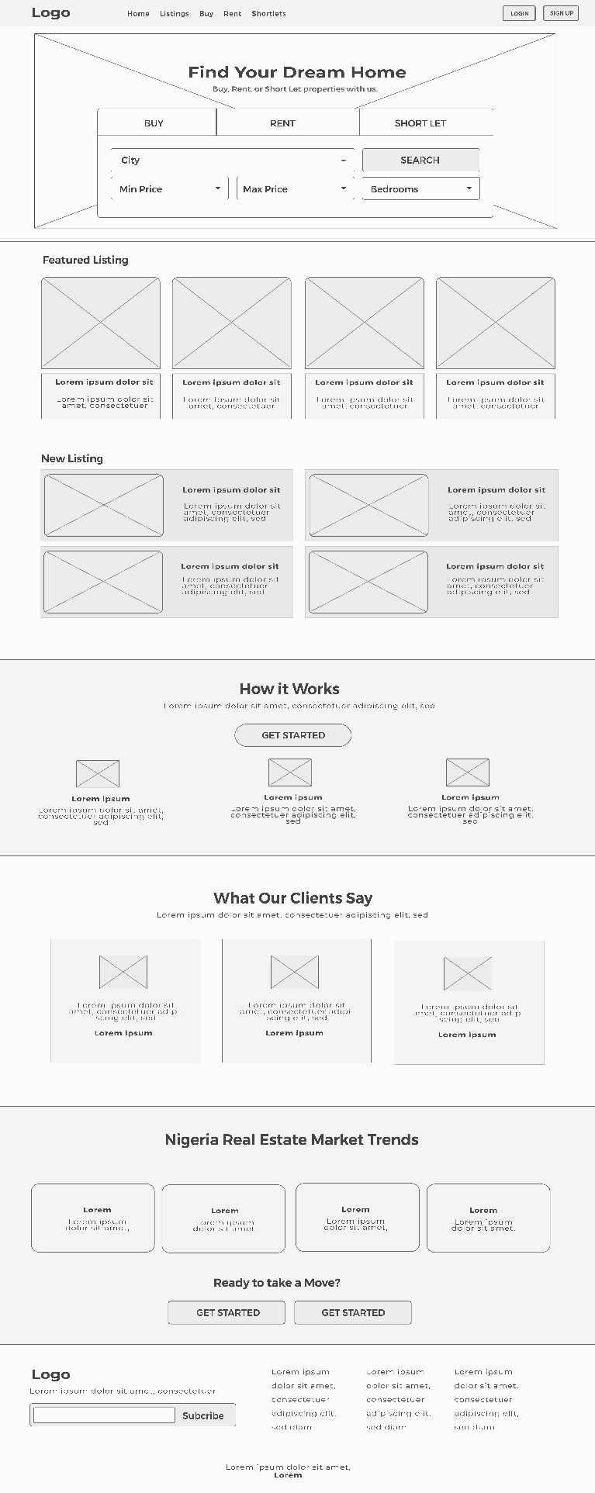

*Figure: Homepage Wireframe*

2. Property Listings Page Wireframe

This display presents the filtered listing results that appear following a search with available sorting features and distinct cards.

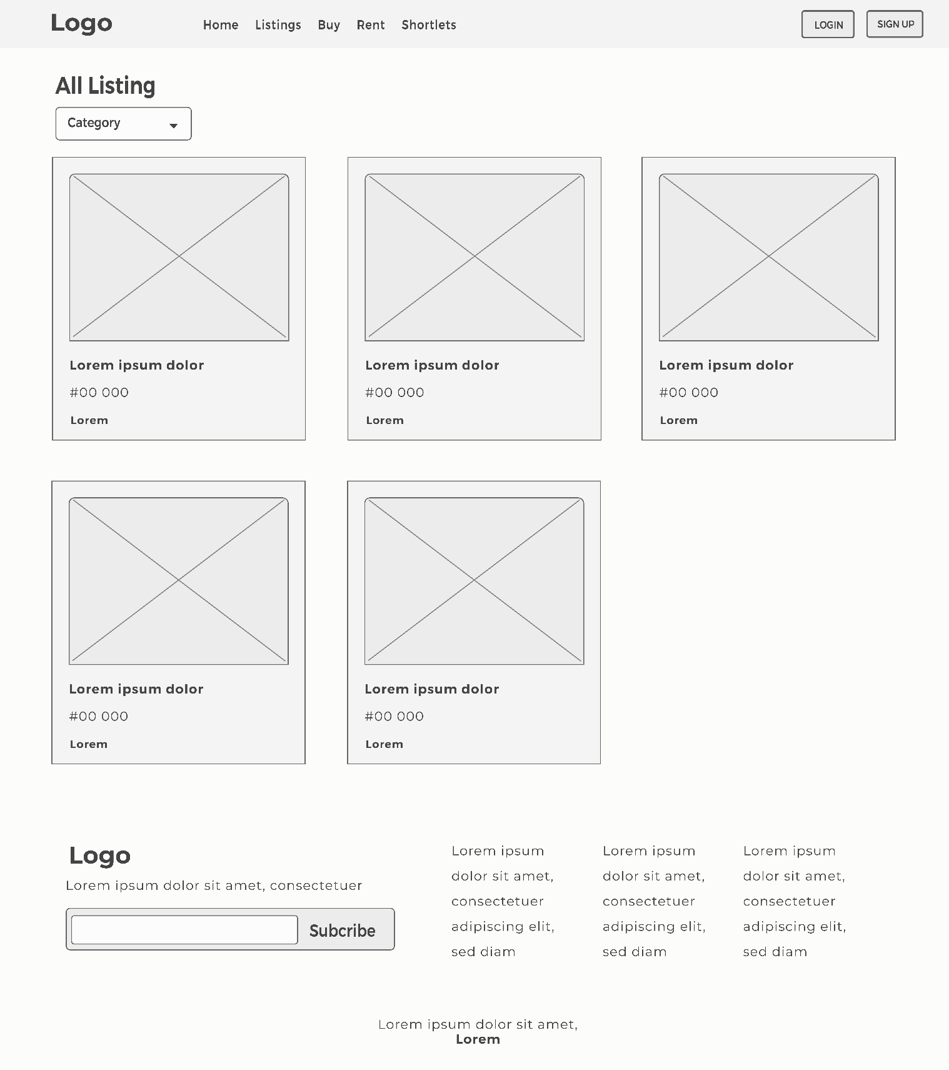

*Figure: Property Listings Wireframe*

3. User Dashboard

The platform shows saved listings in addition to client inquiry tools and profile management interfaces.

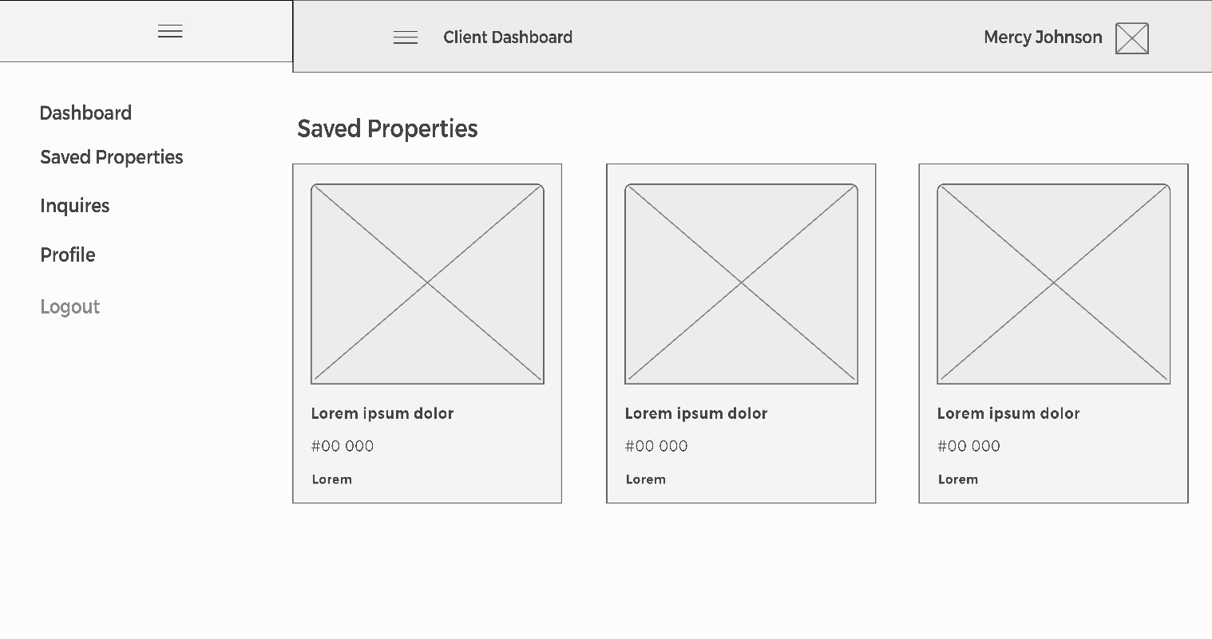

Figure: User Dashboard Wireframe

4. Agent Dashboard

On this panel agents can view and manage listings with inquiry responses and access performance data.

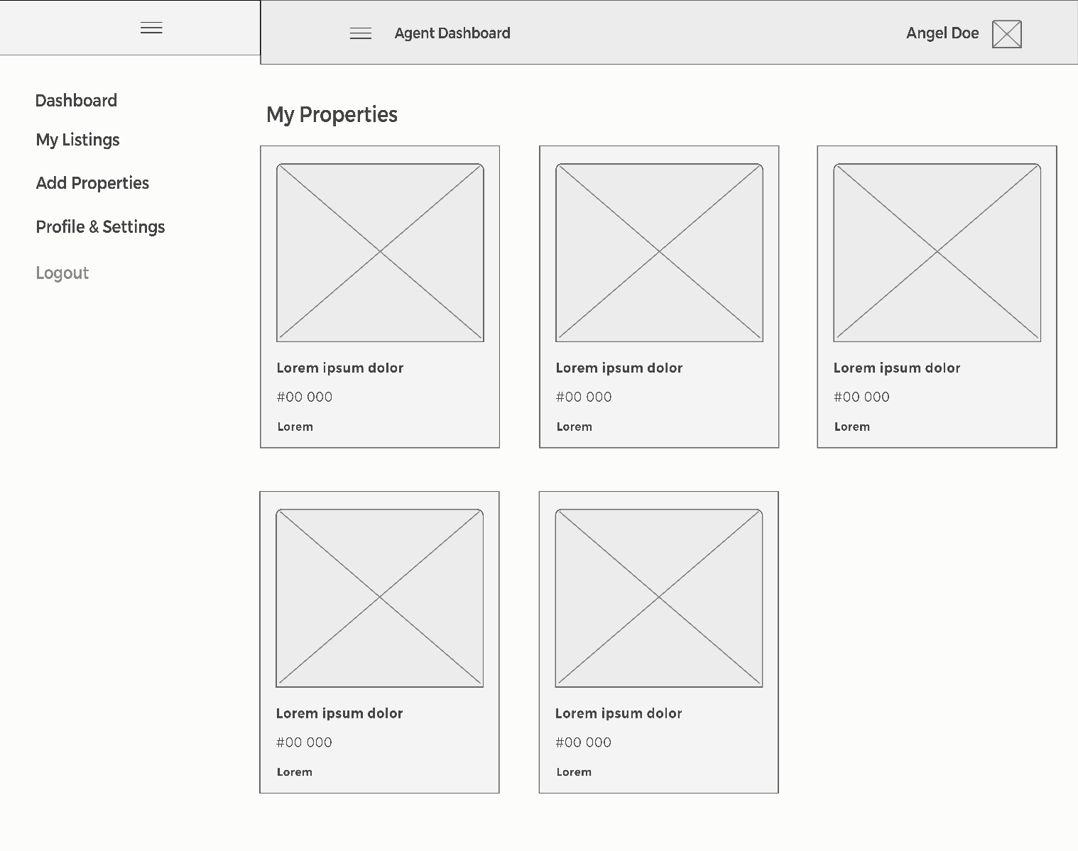

*Figure: Agent Dashboard Wireframe*

5. Search Interface Wireframe

This screen allows users to search properties by keyword, location, price range, and number of bedrooms. The layout includes filter options and a list of search results.

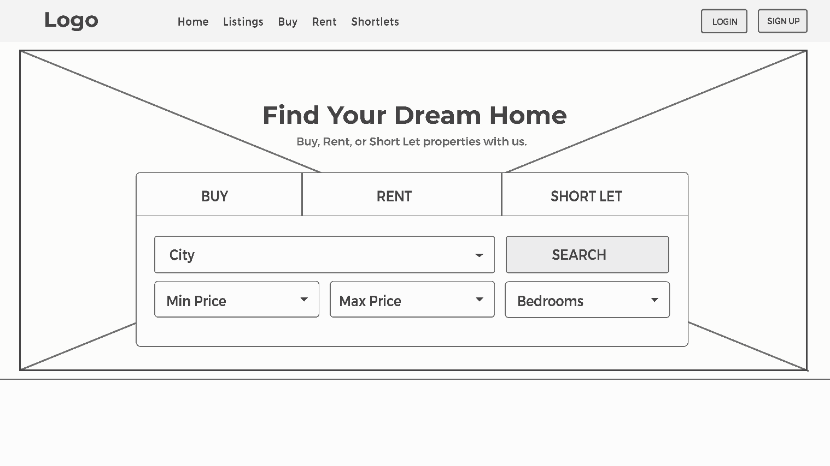

Figure: Search Interface Wireframe

6. Login Screen Wireframe

The login page presents a simple form with fields for email and password, a “Remember Me” option, and password reset link.

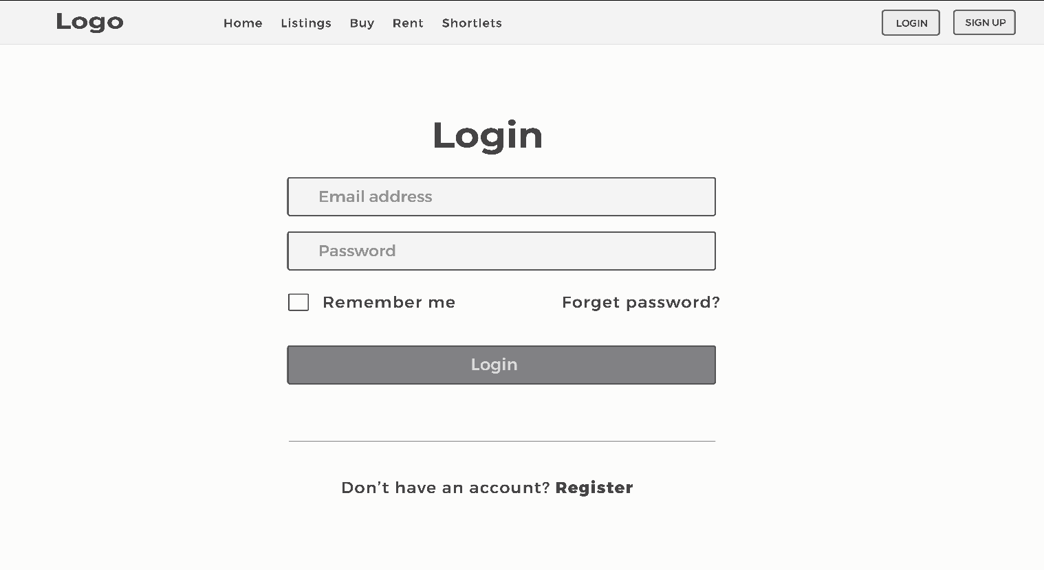

*Figure 5: Login Page Wireframe*

6. Register Screen Wireframe

The registration page includes fields for full name, email, password, and role selection (user or agent), ensuring a smooth onboarding process.

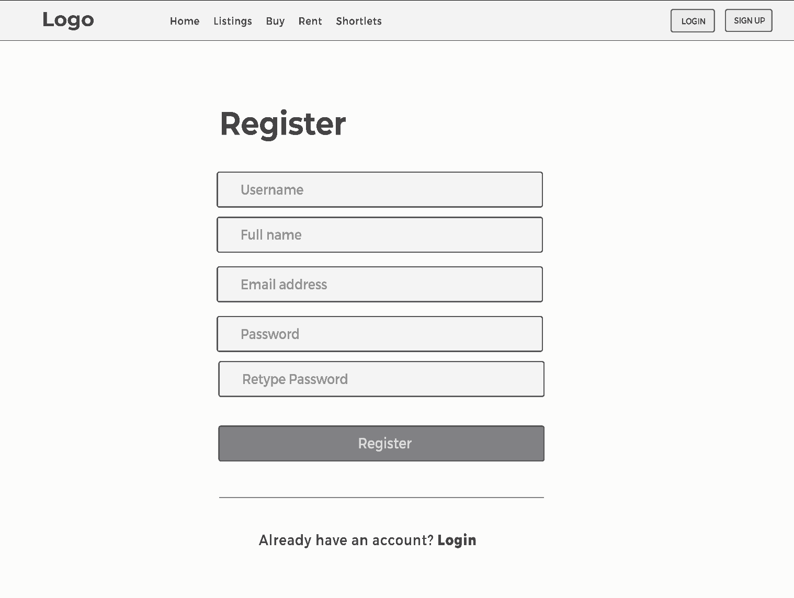

*Figure: Register Page Wireframe*

## Database Design

The system makes use of MongoDB as its document-based NoSQL system to achieve data scalability alongside fast data operations. The system uses MongoDB's schema-less nature but employees Mongoose as an ODM tool to define database schemas while maintaining field data types and relational integrity.

Design Strategy

Hybrid Approach (Referencing & Embedding):

The database schema used both referencing techniques and embedding approaches to achieve proper data normalization along with optimized query execution time. For instance:

* The application normalizes user access types (admin client agent) together with property listings by creating linked references.
* Frequently needed data related to location within Property is embedded because it allows faster read operations.

Collections Overview:

* User: The User collection contains complete user accounts and it keeps embedded fields for agent account specifications.
* Property: The model includes property information that references the agents through external connections.
* Wishlistings: The wishListings data belongs to users in the form of an array of ObjectId references located inside the User model for optimal performance.
* Inquiry & Subscription: The Inquiries and Subscriptions data reside in distinct database collections linked through ObjectIds for independent growth and management separation.

As part of Data Integrity & Validation all fields accept input through Mongoose schema validation and also react-hook-form validations. The data validation system uses custom validators that verify phone number patterns and email patterns in addition to field restriction through enums for category, status and role fields.

Indexes and Role: Multiple compound indexes were built for email addresses along with roles and agentDetails.specialties because these were the most frequently used fields to enhance platform lookup operations.

Scalability: The solution has built-in capabilities to handle future business expansion. The system supports pagination via the database modeling of listings and wishlists alongside plan scalability through schema operation elimination.

“A properly designed database must mirror the natural structure of the real environment. The application's structure relies on the database as its support system instead of being under its control.” — Fowler (2003)

Schema sample:

const PropertySchema = new mongoose.Schema({

title: String,

description: String,

price: Number,

category: String,

location: {

city: String,

state: String,

address: String,

},

bedrooms: Number,

bathrooms: Number,

toilets: Number,

images: [String],

agentId: { type: mongoose.Schema.Types.ObjectId, ref: 'User' }

});

## Backend Implementation

The backend is built using Node.js and Express.js, with endpoints structured according to REST conventions. Middleware ensures modular validation and authentication.

API Endpoints

|  |  |  |
| --- | --- | --- |
| Endpoint | Method | Function |
| **/auth/register** | POST | Register user |
| **/auth/login** | POST | Login and return JWT |
| **/properties** | GET/POST | Fetch/create listings |
| **/wishlist** | POST/DELETE | Manage wishlist items |

Middleware for role-based access:

function verifyRole(role) {

return (req, res, next) => {

if (req.user.role !== role) return res.status(403).send('Access denied');

next();

};

}

Frontend Implementation

React.js, along with Redux Toolkit, manages application state and renders components dynamically. UI components are modular and reusable.

Component Architecture

* PropertyCard: Displays listings
* AgentProfile: Showcases agent credentials
* AdminDashboard: Manages users/properties
* Wishlist: Client's saved items

Forms & Validation

* Form Library: react-hook-form
* Validation Schema: Custom or yup schemas
* Feedback: Inline error messaging for UX improvement

Security Implementation

Security was prioritized using modern libraries and encryption techniques:

* JWT: For secure, stateless authentication
* Bcrypt: Encrypts passwords
* Helmet.js: Protects against known vulnerabilities
* Input Validation: Prevents injection attacks (Mozilla, 2023)

Deployment and CI/CD

Hosting Services

* Frontend: Vercel
* Backend: Railway
* Database: MongoDB Atlas

CI/CD Pipeline

* Version Control: GitHub
* Automation: GitHub Actions for testing and deployment (GitHub Docs, 2024)

Testing Strategy

Testing Tools

* Postman: API testing
* Jest: Unit testing for functions
* Manual Testing: Role-specific interaction paths validated across browsers

Design Decisions and Justification

1. Role-Based Architecture: Improves clarity and access control.
2. Hybrid Database Modeling: Combines embedding and referencing for speed and integrity.
3. Component-Based Frontend: Ensures reusability and maintainability.
4. Green UI Theme: Aligns with psychological cues of safety and trust (Lidwell et al., 2010).
5. UML Modeling: Provided a foundation for consistent, scalable system design (Booch et al., 2005).

Summary

This section illustrates the in-depth system design and implementation of a MERN-based rental application using appropriate software engineering methodologies. From architectural modeling to component-level design and deployment strategies, every decision is supported by proven practices and contemporary tools. UML diagrams, design patterns, and deployment workflows enabled a scalable and secure platform tailored to distinct user roles.

System Implementation and Testing

## Frontend Implementation

The user interface development in the rental application used React.js as its framework which Facebook developed for front-end development. The development team selected React.js because it provides efficient state logic management and its component-based architecture. The application uses Redux Toolkit for state management purposes alongside its tools for simplifying Redux setups while enforcing industry-standard practices. The application design and layout system received support from Material UI (MUI) which offers React developers a popular UI framework that provides consistent accessible components alongside responsive design features.

Component Architecture

The system implements a method to divide its components into three distinct groups according to concern type.

* Atomic Components: Basic UI elements (buttons, input fields, icons)
* Visual components at the atomic level include basic input forms while atomic grouping produces molecular interfaces (search bars and image sliders are examples).
* Organism/Container Components: Full sections or reusable feature modules (e.g., PropertyCard, AgentProfile, Dashboards)

The system has been designed following Atomic Design principles by Frost (2016) so its components can be consistently reused throughout the user interface while promoting collaborative development practices.

Table: Key UI Components and Responsibilities

|  |  |
| --- | --- |
| **Component** | **Role/Responsibility** |
| Navbar | Provides global site navigation. Adjusts visibility based on authentication state. |
| PropertyCard | The essential information about listings appears on the display consisting of image and title and location and price data etc. Supports wishlist. |
| PropertyForm | The system uses this section to let users build and modify their listings. The component supports image importing together with data validation functions along with state tracking systems. |
| AgentProfile | Showcases agent bio, contact, and listing history. |
| AdminDashboard | Enables role-based access to manage users, listings, and reported content. |
| ClientDashboard | Allows clients to view/manage saved listings, inquiries, and profile information. |
| Wishlist | Displays client’s favorited listings. Supports remove/add functionality. |
| Login/Register Form | Handles authentication with form validation and conditional rendering. |
| FeaturedListing | Implements responsive slider for featured listings |
| FilterBar | The system allows users to search properties through category, price ranges and location specifications. |
| ProfileForm | This system component allows users to maintain their account information according to their assigned access permissions. |
| InquiryList | Allows clients to view their submtited booking requests and responses from agents/admins. |

The components work as reusable units while being aware of their context which simplifies their integration across multiple pages. PropertyCard operates without change across various pages that include main property displays as well as wishlists and profiles dedicated to agents.

## Code Organization Strategy

The organization of development relies on feature-based folders through a Domain-Driven Design (DDD) structure.

Benefits of This Architecture

* The components PropertyCard and Navbar get applied across multiple views through prop-based adjustments.
* The application scalability benefits from the addition of new components which results in no impact on the operation of existing components.
* Easier maintenance occurs because isolated components keep debugging simple when placed alongside well-structured code.
* React.memo and useMemo along with useCallback hooks provided by React improve rendering speeds most significantly in elements with numerous listings.

Styling Strategy

The application applies Material UI (MUI) throughout its components to ensure standardization of visual design. Users can customize MUI components using the sx prop along with theme overrides. From MUI's base components all existing buttons alongside text fields and alerts derive their structure which avoids the requirement for unique CSS coding while preserving accessibility standards (MUI Docs, 2024).

Responsive Design Considerations

MUI Grid system and media queries form the basis for responsiveness in the application. The design convention of starting mobile accessibility first allows interface components to function efficiently at all screen dimensions. For instance:

* On mobile screens the navbar becomes accessible through the hamburger menu.
* The layout of the ClientDashboard, AgentDashboard, Admin Portal changes from sidebar to tab configuration when the screen size becomes smaller.

## Backend Implementation

The MERN-based rental application built its backend through Node.js and Express.js framework thus delivering APIs using RESTful standards while maintaining high scalability and strong performance capabilities. The application implements thorough user role administration along with CRUD functionality and image management while storing data through the MVC design pattern. The pattern enables maintenance-friendly design and distinct logical separation between different application components (Fowler, 2002).

Project Structure

The project adheres to a modular folder-based structure for clarity and scalability. Each directory serves to contain logics which focus on particular application layers.

src/

├── config/ *DB connection and Cloudinary setup*

├── controllers/ *Business logic and API controllers*

├── middleware/ Authentication, error handling, role checks

├── models/ Mongoose schemas

├── routes/ *Express route handlers*

├── utils/ *Reusable helpers (e.g., email, validation)*

app.js *Express app initialization*

server.js *Entry point to the application*

.env *Environment variables*

## MongoDB Schema Design

Our application stores data through MongoDB Atlas which acts as its NoSQL database available on the cloud platform. The schema implementation takes a dual implementation approach by integrating embedding with referencing to achieve high performance while keeping data consistency.

Cloudinary Integration for Image Upload

Cloudinary provides secure.Cloud-based image storage features and image transformation capabilities which operate through its API. Using this configuration eliminates the need for local storage thus achieving faster operations alongside better scalability levels.

* The middleware application Multer controls the process of receiving multipart/form-data file uploads.
* The application moves upload data through utils/cloudinary.js to Cloudinary through helper functionality from Multer.
* The frontend presentation displays URLs that originate from Cloudinary after storing them in a MongoDB database.

This indicates that the strategy delivers images through their CDN network along with their transformation capabilities (Cloudinary Docs, 2025).

## Authentication and Authorization

The system uses these approaches for maintaining security measures and role divisions:

1. JWT (JSON Web Tokens):

The generation of tokens occurs during login and the Authorization header contains these tokens which protect further requests. Sessions are first validated by the authMiddleware as it verifies the tokens.

1. Role-Based Access Control (RBAC):

The roleMiddleware verifies users for administrator or agent or client access before permitting them to view protected routes which contain AdminDashboard and AgentPropertyManager pages.

1. Password Hashing with Bcrypt:

Bcrypt hashes passwords to protect them when data storage occurs because data breaches no longer represent a risk to security.

## User Profile Controller

The UserProfileController allows users to fetch and modify their account information. Each user has restricted access:

* Users with clients roles have access to modify their name and email, phone number and avatar picture.
* The system allows professional detail management for agents but prevents them from accessing any modifications to account core information.
* The system enables administrators to view and control all user accounts but they lack permission to alter client information without proper justification.

*The application uses Joi or Yup for validation purposes while securely processing updates through PATCH method requests.*

## Inquiry and Booking System

Clients use the Inquiry model to initiate interest messages through the booking system before booking agents. The process includes:

* The booking request process starts on property detail pages when clients utilize the designated form.
* The inquiries collection receives new entries when property and user data is stored within them.
* Administrators and agents can view incoming inquiries through their control dashboards after which they can start replying.
* Bookings become more transparent to clients through the system status markers which show pending, approved and declined states.

*The system implements communication features and matches the client-agency relationship that occurs in everyday interaction.*

Security Features (Cross-section)

|  |  |  |
| --- | --- | --- |
| **Feature** | **Technology Used** | **Purpose** |
| Password Encryption | Bcrypt | Prevent password exposure |
| Authentication | JWT | Stateless session control |
| Input Validation | Yup / Joi | Prevent injection attacks |
| HTTP Headers | Helmet.js | XSS, CSP, and other headers for attack prevention |
| HTTPS Enforcement | Railway + Vercel | Secure transport of sensitive data |

## Security Implementation and Testing

Modern web applications designed to process user data require security as their base foundation that keeps a real estate rental platform operational. Every component in the Rental-App-MERN project follows a security-first approach by using industry-established security techniques and tools for data protection as well as unauthorized access prevention and system integrity protection throughout all client and server sections.

The major security implementation aspects along with their testing procedures that validated system reliability will be analyzed in this section.

## Testing Strategy

The application requires testing to verify its functionality and reliability alongside its performance metrics. The testing approach used manual along with automated testing methods to verify every module functions properly across various user situations and environmental conditions. Testing approached the system through frontend testing and backend testing and API testing while testing each workflow using three user roles: admin, agent, and client.

## Testing Tools and Techniques

| Tool | Purpose | Usage |
| --- | --- | --- |
| Postman | API endpoint testing | Manually test CRUD operations, authentication, and search routes |
| Jest | Unit testing framework for JS | Backend function tests, e.g., validation and controller logic |
| React Testing Library | Component and integration tests | Test UI behavior and user events on the frontend |
| Browser DevTools | Manual inspection | Validate responsive layouts and runtime logs |
| Manual Role-Based Testing | Simulated user behavior | Verify access controls for Admin, Agent, and Client |

## Backend API Testing with Postman

Testing of backend APIs required a complete set of examinations through Postman API operations. The testing route nel included security validation along with controls for property administration options along with wishlist handling and management features for administrator roles.

The API tests performed checks with varying conditions that included legitimate and illegitimate data as well as proper and improper tokens and specific role permission tests. Selected Postman requests from below demonstrate the demands and responses together with short descriptions.

Some Routes and Their Testing Outcomes:

| HTTP Method | Endpoint | Description | Status Code | Tested Roles |
| --- | --- | --- | --- | --- |
| POST | /api/auth/register | Register a new user (client or agent) | 201 Created | Public |
| POST | /api/auth/login | Authenticate user and return JWT | 200 OK | Public |
| GET | /api/users/profile | Get current user's profile | 200 OK | Authenticated |
| PUT | /api/users/profile | Update user details | 200 OK | Authenticated |
| GET | /api/properties | Fetch all listed properties | 200 OK | All |
| GET | /api/properties/:id | Fetch single property by ID | 200 OK | All |
| POST | /api/properties | Create a new property listing | 201 Created | Agent, Admin |
| PUT | /api/properties/:id | Update listing details | 200 OK | Agent, Admin |
| DELETE | /api/properties/:id | Delete property listing | 204 No Content | Admin |
| GET | /api/wishlist | Fetch client’s saved listings | 200 OK | Client |
| POST | /api/wishlist/:propertyId | Add a property to wishlist | 200 OK | Client |
| DELETE | /api/wishlist/:propertyId | Remove from wishlist | 200 OK | Client |
| POST | /api/inquiries | Submit an inquiry (booking) | 201 Created | Client |
| GET | /api/inquiries | View submitted inquiries | 200 OK | Client, Admin |
| GET | /api/agents | View all verified agents | 200 OK | All |

*The role-based access control was tested through authorization header JWT token verification for all sensitive routes.*

Screenshot 1: User Registration API (POST /api/auth/register)

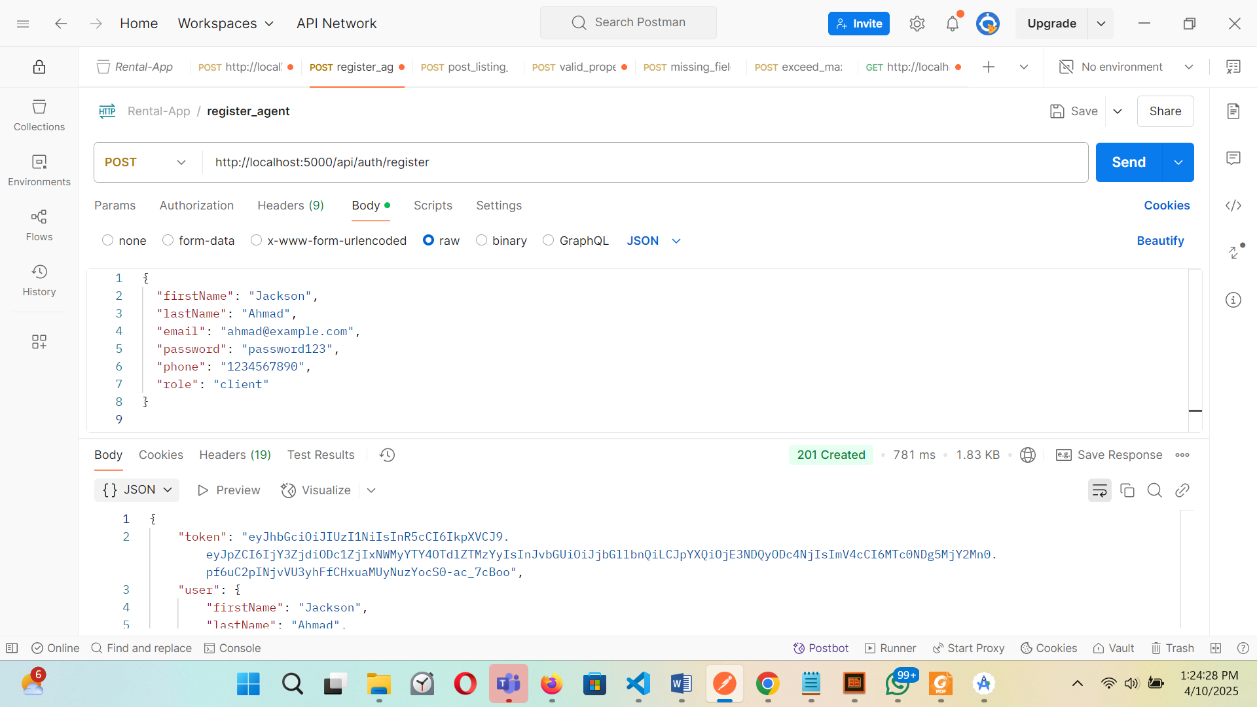  
Figure – Registering a new user via Postman

Description:  
A new user registration succeeded through a POST request containing mandatory fields of name and email along with password and role. The server generated a 201 Created response while providing JSON data containing the user information. This confirms successful user onboarding.

Screenshot 2: Login API (POST /api/auth/login)

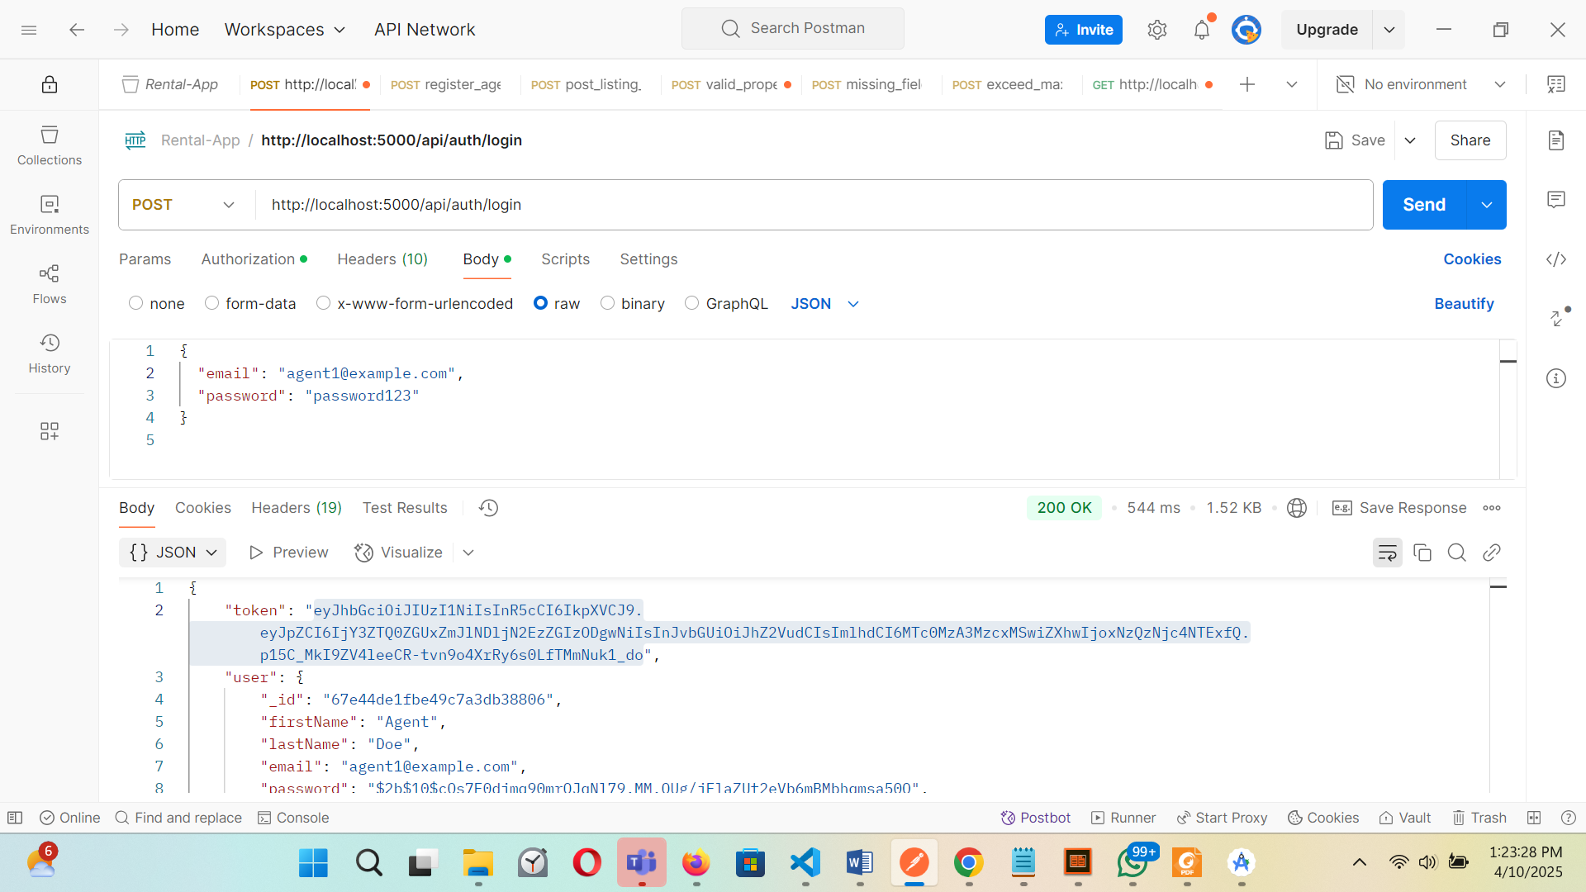  
Figure 6.2 – Logging in with valid credentials

Description:  
The endpoint validation happens through this test. Correct credentials were included in a POST request to the system. A server response included a 200 OK status together with an authentication token and user data. Users can use the issued token for protecting their access to restricted paths in further requests.

Screenshot 3: Create Property (POST /api/properties)

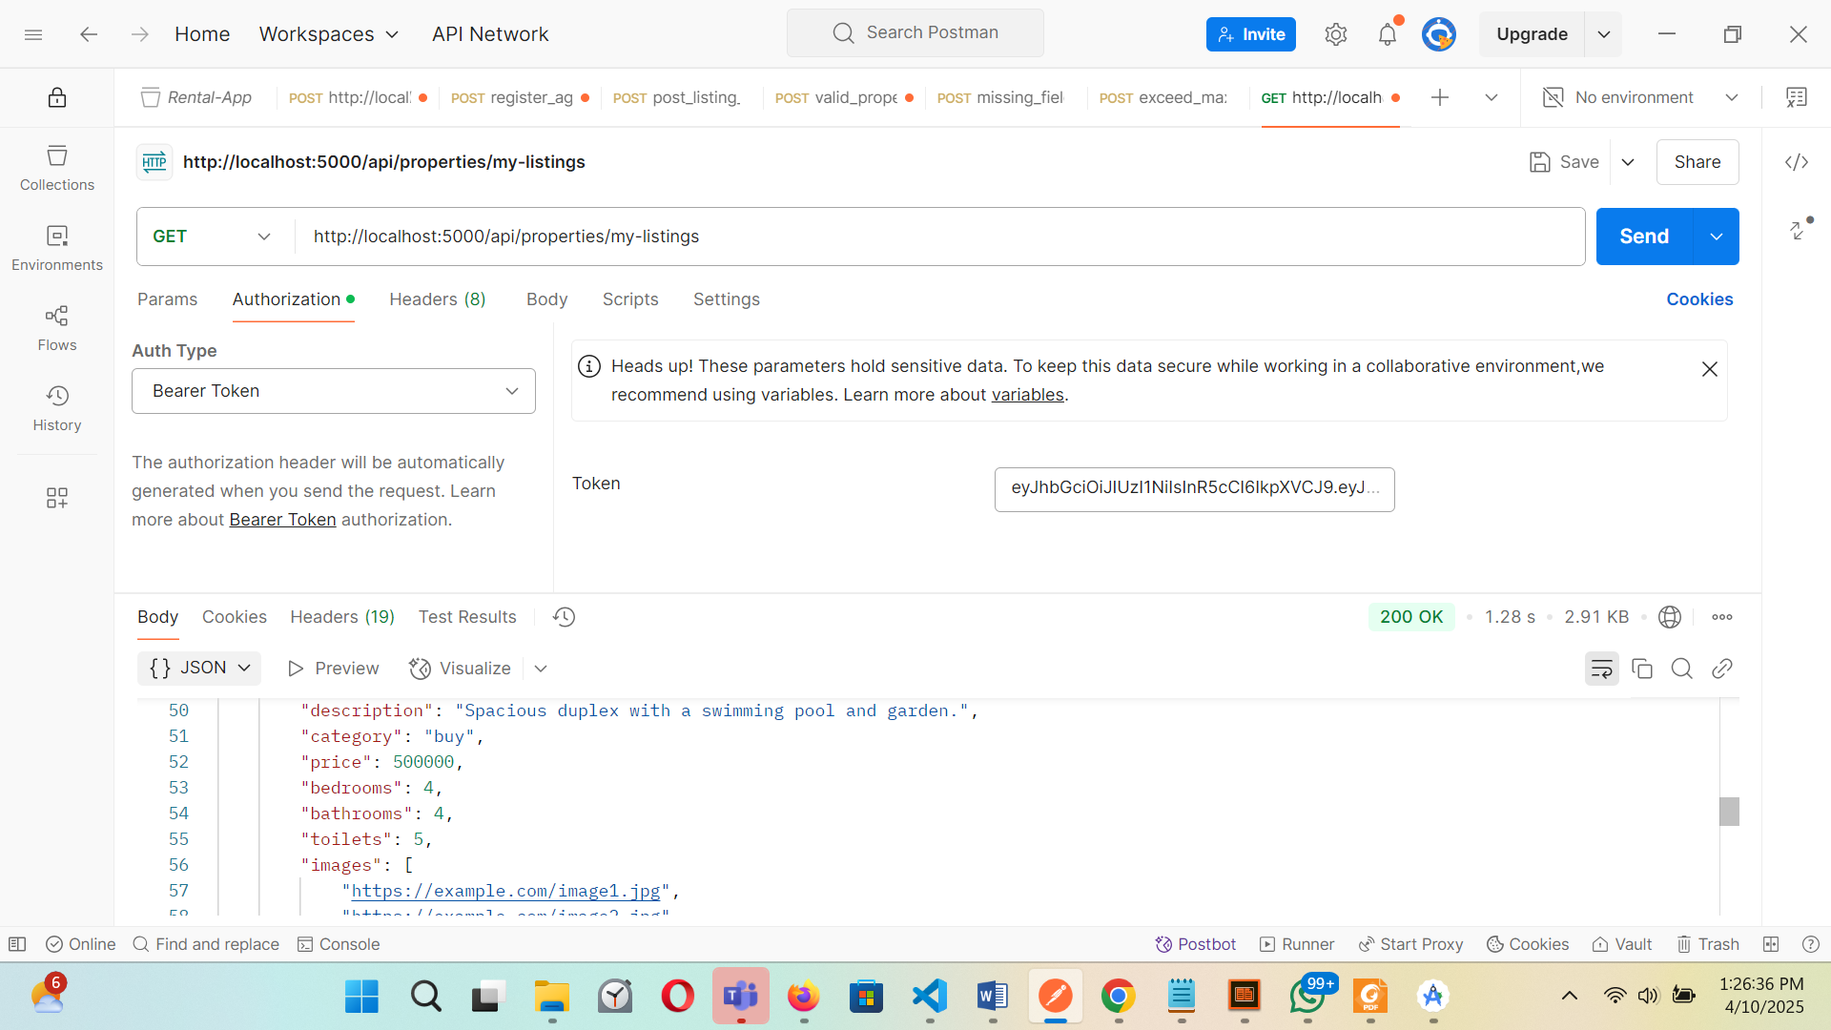  
*Figure 6.3 – Admin or Agent posting a new property*

Description:  
A POST request under authentication conditions allowed an agent to create new properties. A POST request contained necessary fields, which included title, price, location, category and image URLs. The server processed the request, which contained an authentic bearer token before it returned the 201 Created message.

Screenshot 4: Fetch Wishlist (GET /api/users/wishlist)

Figure 6.4 – Client fetching wishlist items

Description:  
The GET request retrieved all properties (wishlist) which the current user had saved while being authenticated with a valid JWT token. The request used a legitimate JWT authentication token for authorization purpose. The server answered with a 200 OK status together with a list containing all property objects which the user had saved.

Screenshot 5: VERIFIED AGENTS AUTHORIZATION (POST /api/properties)

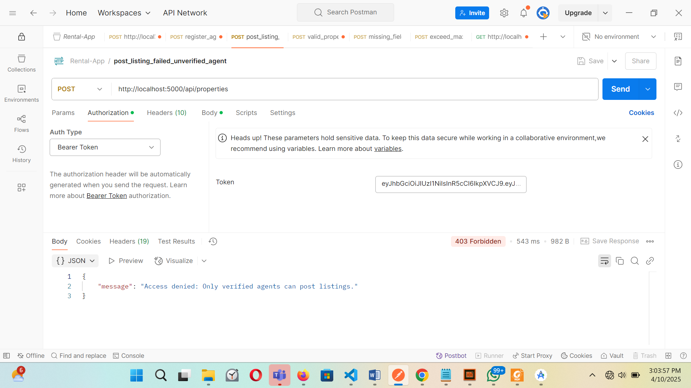  
Figure 6.5 – Non agent or Non verified agents error message

Description:

A user who is a client or unverified agents cannot post properties or send request to /api/properties… that included a valid admin token. The successful outcome of the request included a 201 Created response status, but a failed request results to Access denied, with a response only verified agents can post listings.

6.4.3 Frontend Testing

End-users strongly depend on frontend testing to validate the usability features of their web applications and ensure their interactive quality alongside system durability. Testing on the user interface of the MERN rental application proved essential for correctly executing interface operations and state transition functionality with constant user experience quality.

Testing Strategy and Tools

The frontend went through combined testing methods that included:

* Exploration Testing: The development phase included a process of exploratory testing where tester employed manual methods to detect hidden functionality and screen defects.
* Unit Testing: I conducted Unit Testing on the most important utility functions and Redux actions as well as components independently.
* Integration Testing: The test focused on integration by establishing smooth connections between system components as well as routes and state handling.
* React DevTools and Redux DevTools: The framework provides two DevTools for developers to study component display alongside state modifications in real time.
* Form and Behavior Testing: The team used browser development tools to simulate user actions which verified that the User Interface responded accurately with expected user interface behavior.

## Areas of Focus

1. Form Validation

Objective: The system should validate all input data conforming to predefined standards prior to data submission.

Implementation: Utilized React Hook Form and Yup for schema-based validation.

Outcome: The application shows proper inline message warnings whenever users omit required fields or provide incorrect information across different forms including login, registering, property posting and profile editing.

2. Role-Based Navigation and Access

Objective: A goal exists to ensure users receive access to only those routes their assigned role allows (admin, agent, client) access.

Implementation: The application implements protected routes through the combination of React Router and Redux authSlice.

Outcome:

* Non-authenticated visitors receive the login form as their only destination.
* The dashboards that consist of AdminPanel, ClientDashboard and AgentPanel remain hidden from unauthorized access until proper authentication occurs.

3. Search Functionality

Objective: The SearchBar should prove its ability to communicate with search backend APIs and produce appropriate search results.

Implementation: This phase combines artificial term queries together with city selections and price range requirements along with bedroom quantity specifications.

Outcome:

* The searched results automatically update when users make changes to the filters and select a category.
* Search data displayed by the user interface matches the redux state information.

4. State Management (Redux)

Objective: This test confirms the proper operation of implementing actions to change both the Redux state as well as the user interface.

Tools: Redux DevTools provided a tool for observing dispatched actions and state values changes.

Outcome:

* The application moved between states (user login and wishlist activation and property retrieval) in a predictable and error-free manner.
* The reducer system addressed exceptional cases that included both empty list arrays and duplicate occurrences and network failures.

Example Test Cases

The table below outlines key frontend scenarios and expected results observed during testing:

| Feature | Test Scenario | Expected Result |
| --- | --- | --- |
| Login Form | Submit with empty fields | Inline validation errors shown for each missing field. |
|  | Submit with valid credentials | Redirect to appropriate dashboard based on user role. |
| PropertyCard | Click property card | Redirects to detailed property page with full data display. |
| Client Dashboard | Navigate to "Inquiries" tab | Displays a list of bookings with current statuses. |
| Admin Panel | Click delete icon on a property | Property is removed and success toast is shown. |
| Wishlist Feature | Toggle heart icon on a property | Adds/removes property from wishlist with updated state. |
| Profile Update | Modify user details and submit | Success message shown and profile re-fetches new data. |
| SearchBar | Input city and minPrice | Listings update to reflect the entered filters. |
| Route Guarding | Attempt to visit /admin as a client | Redirects to home or login with a "Not Authorized" message. |

Test Coverage Highlights

The search function had its edge conditions tested through:

* No results found
* Missing filters
* Multiple filters combined

Error Handling: The application's error management system demonstrates smooth behavior for backend errors which produces suitable feedback.

Mobile responsiveness: Mobile responsiveness verification occurred by using simulation tools and dev tools with responsive modes.

Accessibility Check: The accessibility reviews comprised portable tests that verified color contrast ratios alongside keyboard operation and easily understandable labels through Lighthouse audits.

Demonstration / Evaluation

## Introduction

The chapter illustrates how the practical aspects of the MERN-based rental application function while assessing its effectiveness in meeting specified functional and non-functional requirements from Chapter 3. The application's capabilities become accessible through walkthrough illustrations of its interface and screenshot annotations in this section. The project includes performance benchmarks together with project management evaluations derived from the initial Gantt Chart to demonstrate technical sophistication and managerial execution of the project.

## Application Walkthrough

The walkthrough outlines significant application modules and user processes and essential features while using screenshots with annotations together with descriptive explanations. Users who access the application log in as Clients Agents or Admins which allows them to access their distinctive dashboards.

Landing Page & Hero Section

A modern green-themed interface exists on the landing page to create an attractive design.

A background image fills the whole screen through a semi-transparent film provides an elegant visual experience.

The Hero Section includes:

A bold title and subtitle

Users can choose property categories through the Buy-Rent-Short Let tabs located on the page.

The SearchBar contains MUI Grid2 along with fields for Keyword as well as City and Minimum, Maximum Price and Bedrooms. It displays correctly on any screen size.

* Keyword
* City
* Minimum and Maximum Price
* Bedrooms

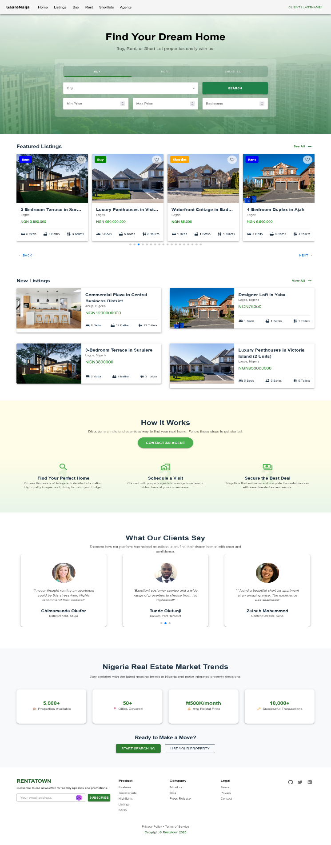

*Screenshot 7.1: Landing Page showing Hero Section with tabbed search.*

Property Listings

The page displays PropertyCards inside a grid which obtains their information from Redux backend services.

The key information including price and title and location and thumbnail image and category icons is presented on Cards.

Features:

* Pagination
* Property listings can be filtered based on the category and location and value span alongside bedroom availability
* The system allows users to view listings according to the most recent listings and the ones marked as featured.
* The system gets updated immediately when users add new information to the system.
* The system allows users to place properties in their wishlist section.

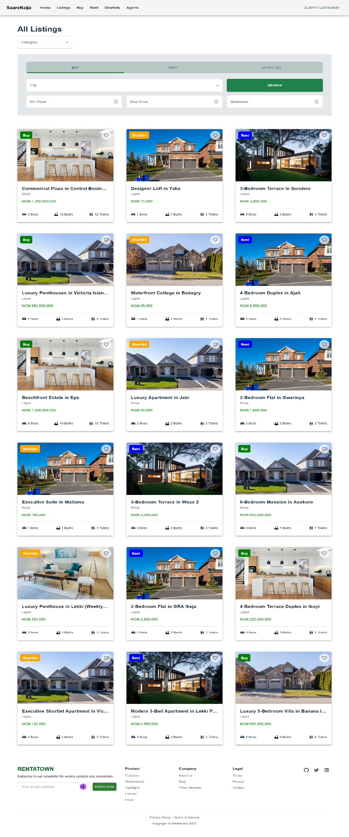

*Screenshot 7.2: Listings Page with dynamic filters and responsive property grid.*

Property Detail Page

Users experience a detailed two-column format after accessing individual properties.

Left Panel: Auto-playing image carousel

Right Panel: of the page includes pricing details together with location information and description along with features and agent contact details.

Users (clients) can:

* The system allows users to place properties in their wishlist section.
* The user should contact the agent through the integrated inquiry form which appears directly on the platform.
* Read complete agent profiles together with their full list of properties.

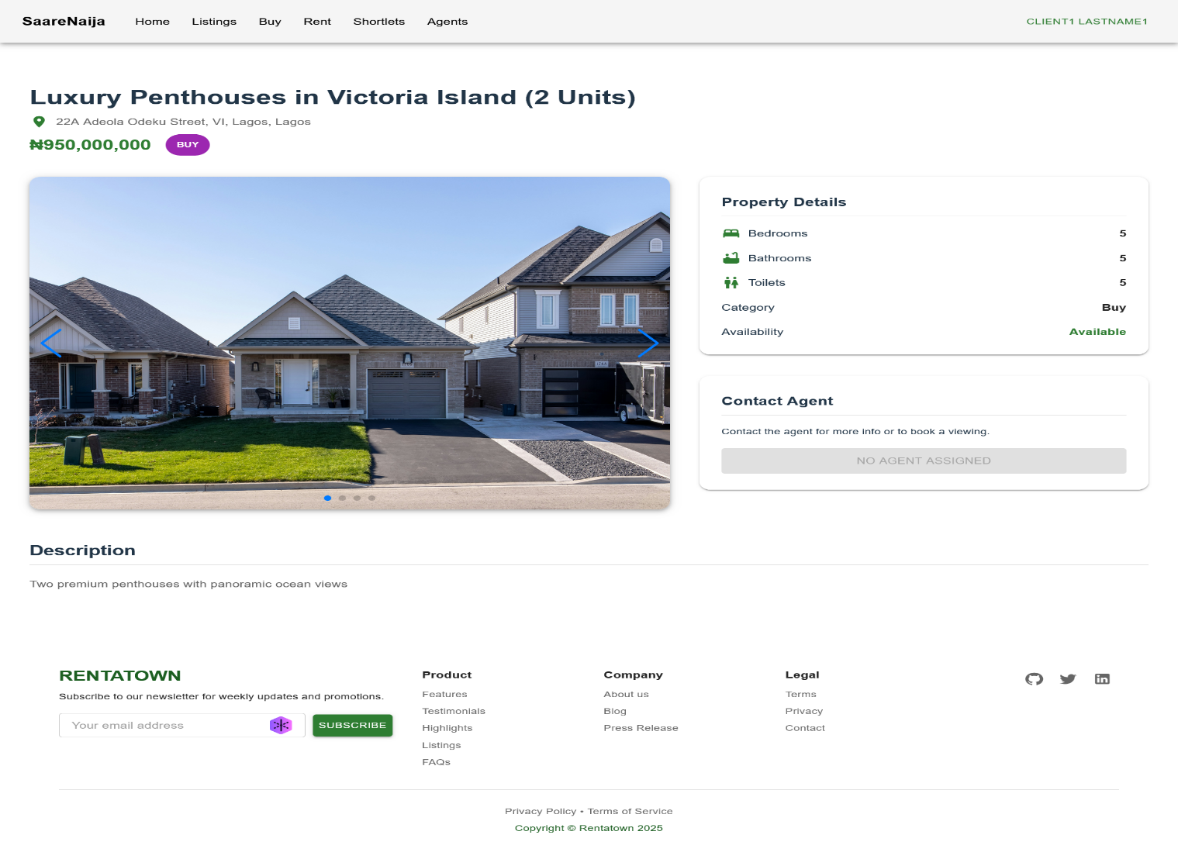

*Screenshot 7.3: Property Detail View with gallery and contact features, Unverified Agent.*

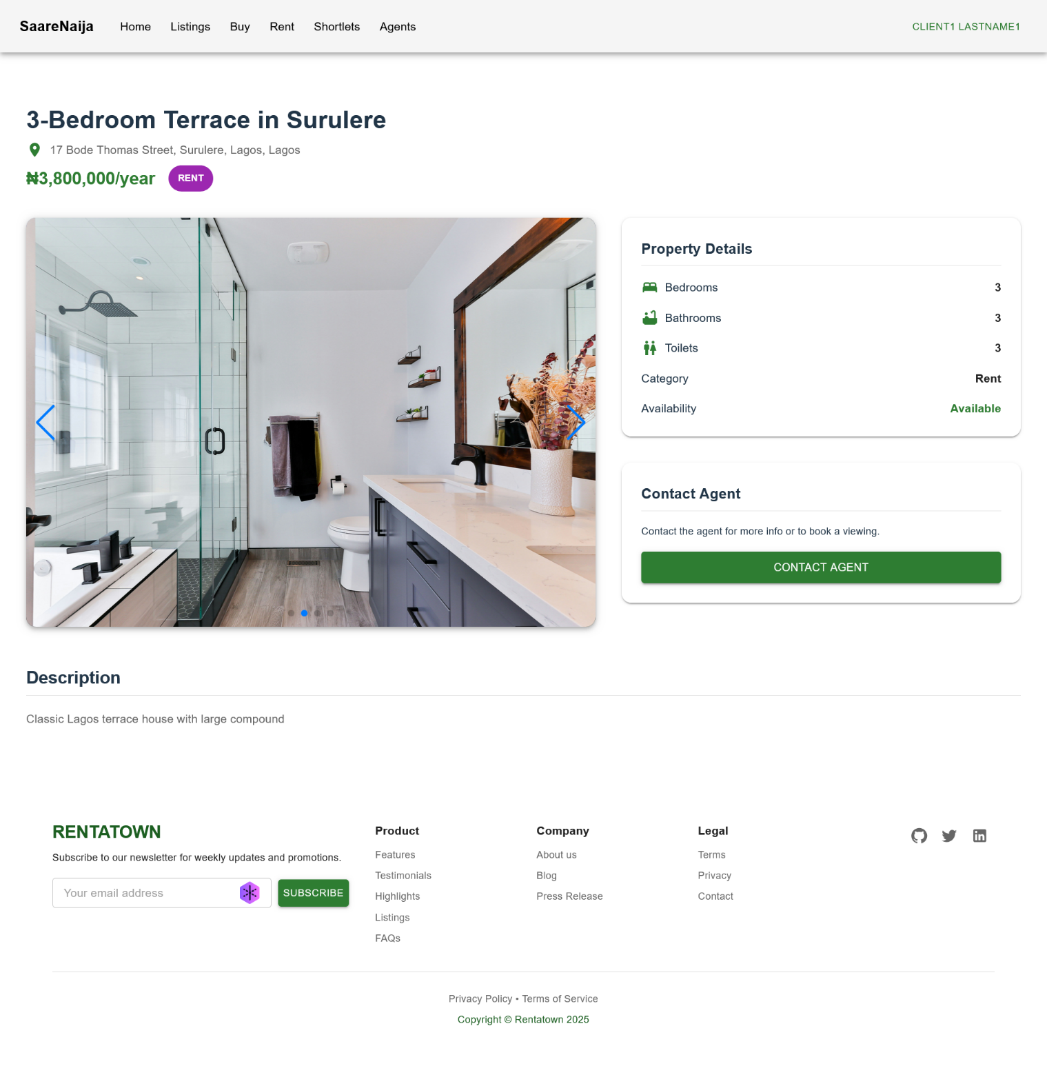

*Screenshot 7.3: Property Detail View with gallery and contact features, Verified Agent.*

## User Authentication

Authentication through JWT serves as a basis for the system while allowing specific role logins.

* Client
* Agent
* Admin

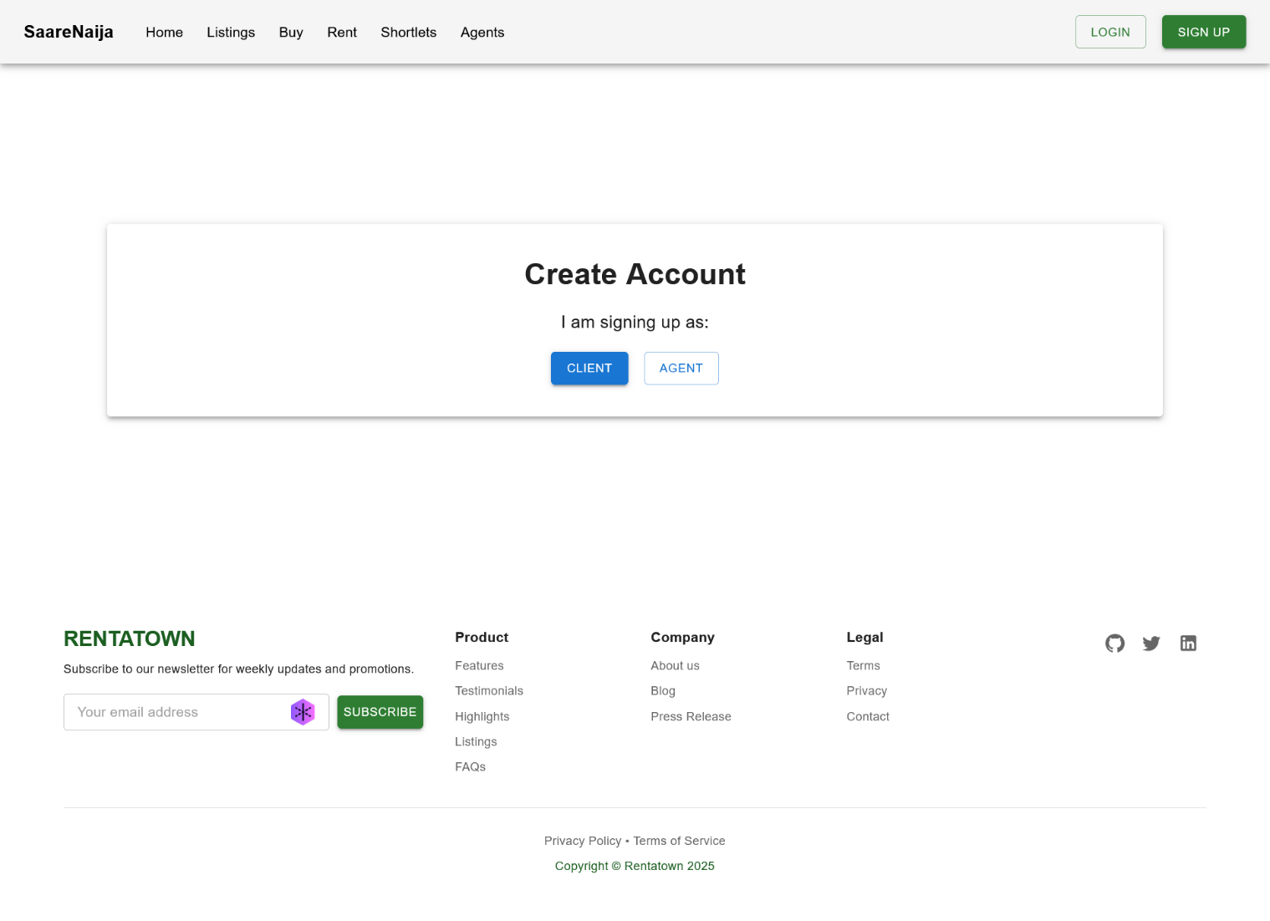

*Screenshot 7.3: Register prescreen and sign up as a client or agent.*

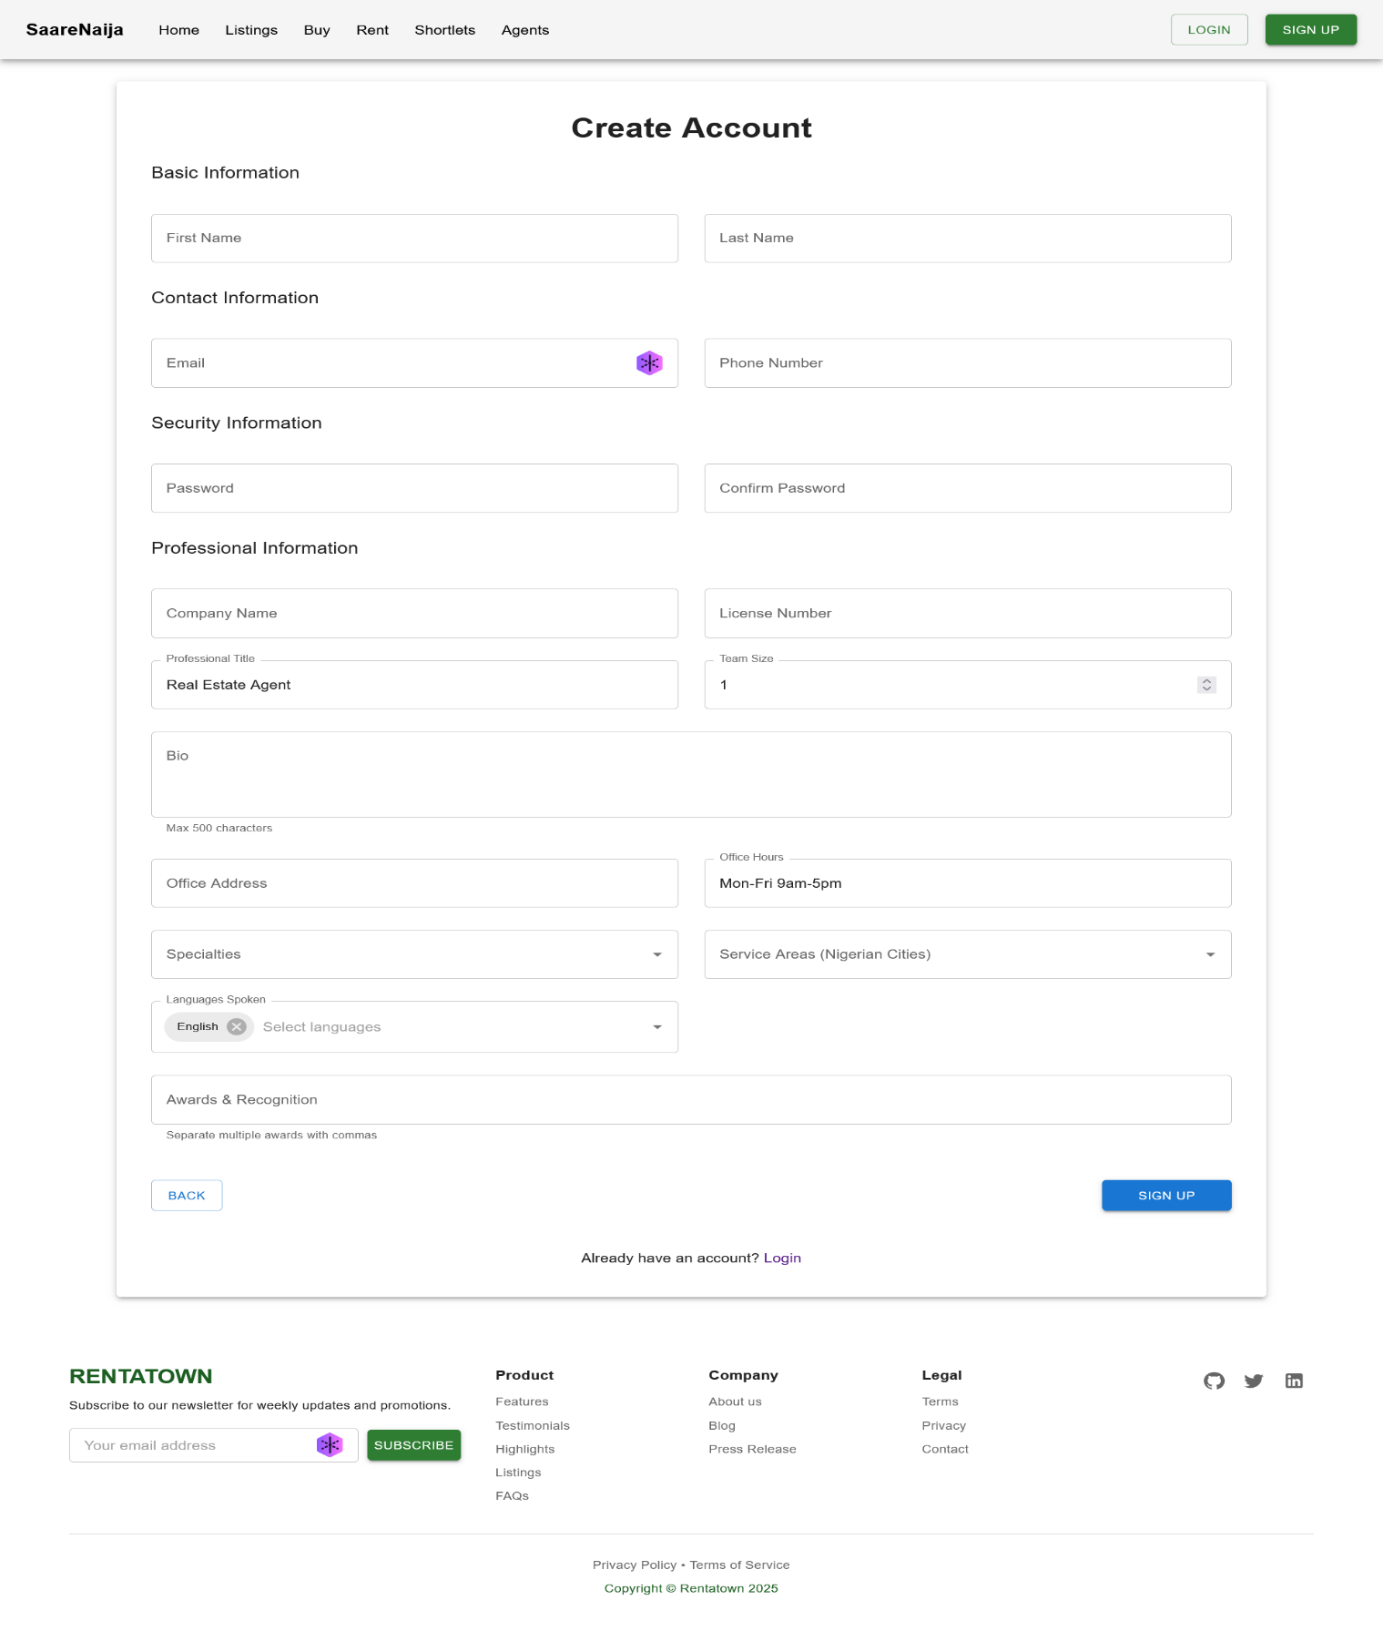

*Screenshot 7.3: Register as agent, and wait admin verification.*

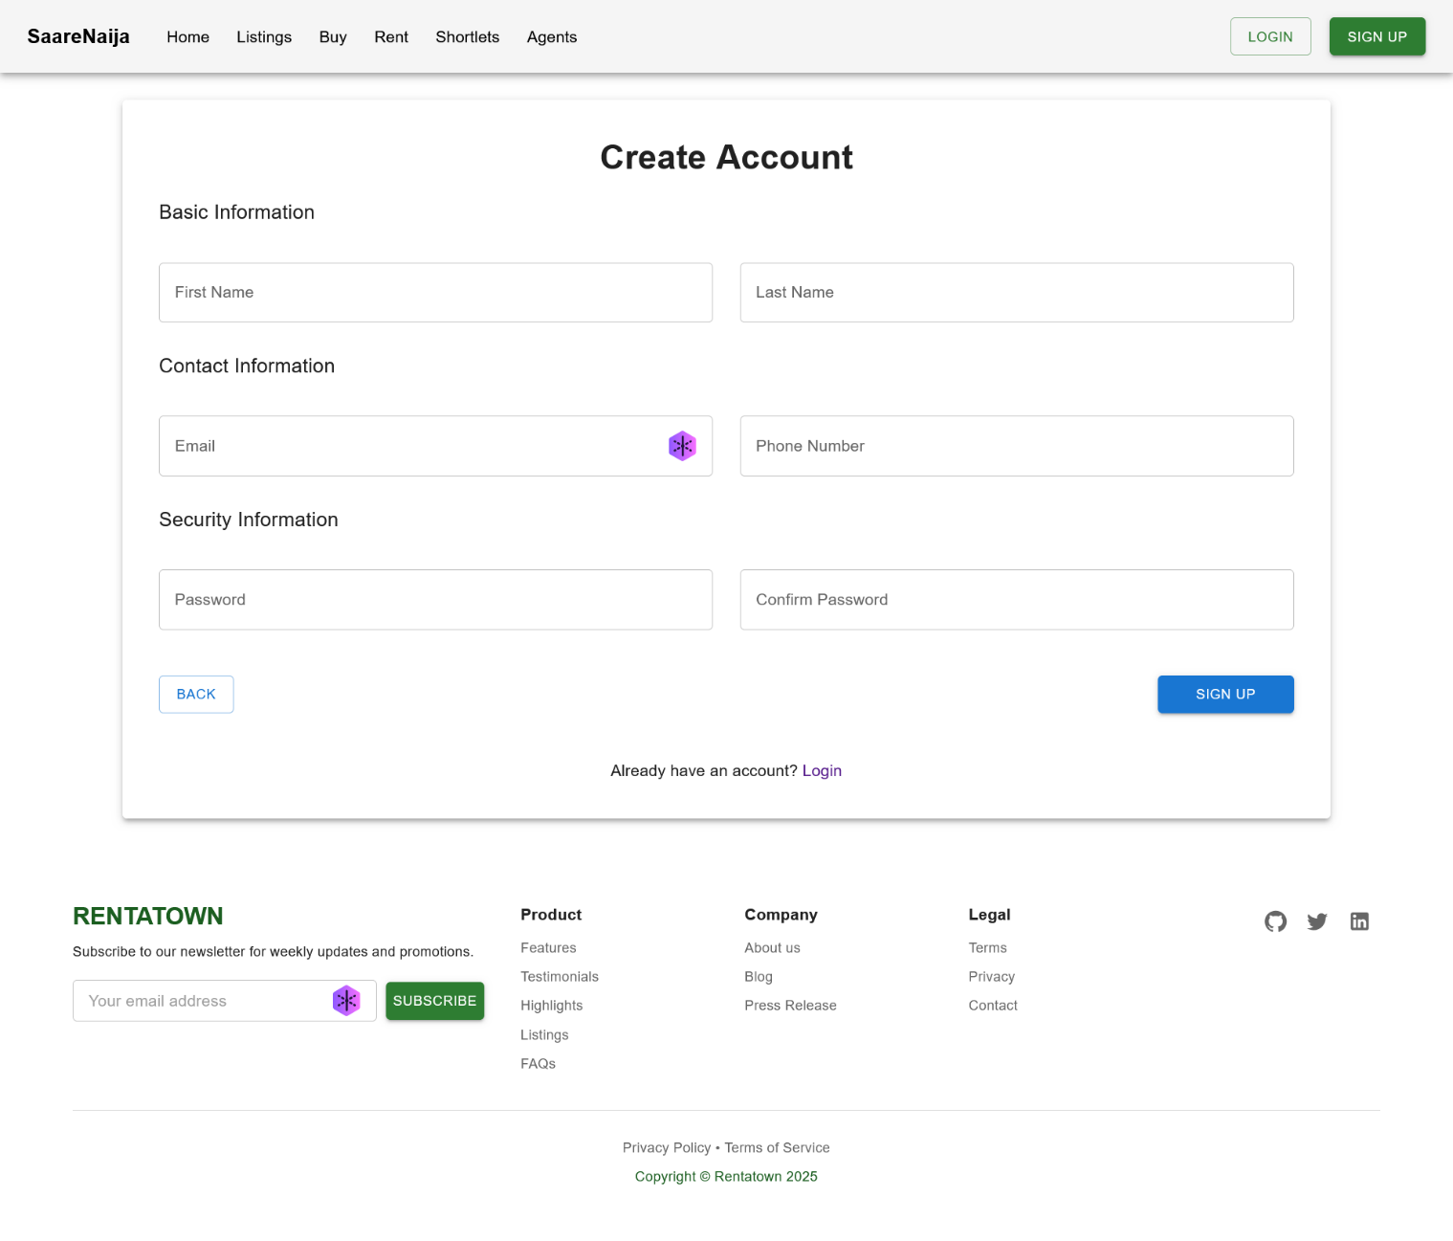

*Screenshot 7.3: Screen Register as client.*

Upon successful login:

* After successful authentication users will reach their designated dashboard view.
* The middleware system stops unauthorized users from accessing the system.
* React Hook Form functions as a validation tool which shows error messages directly on the form fields

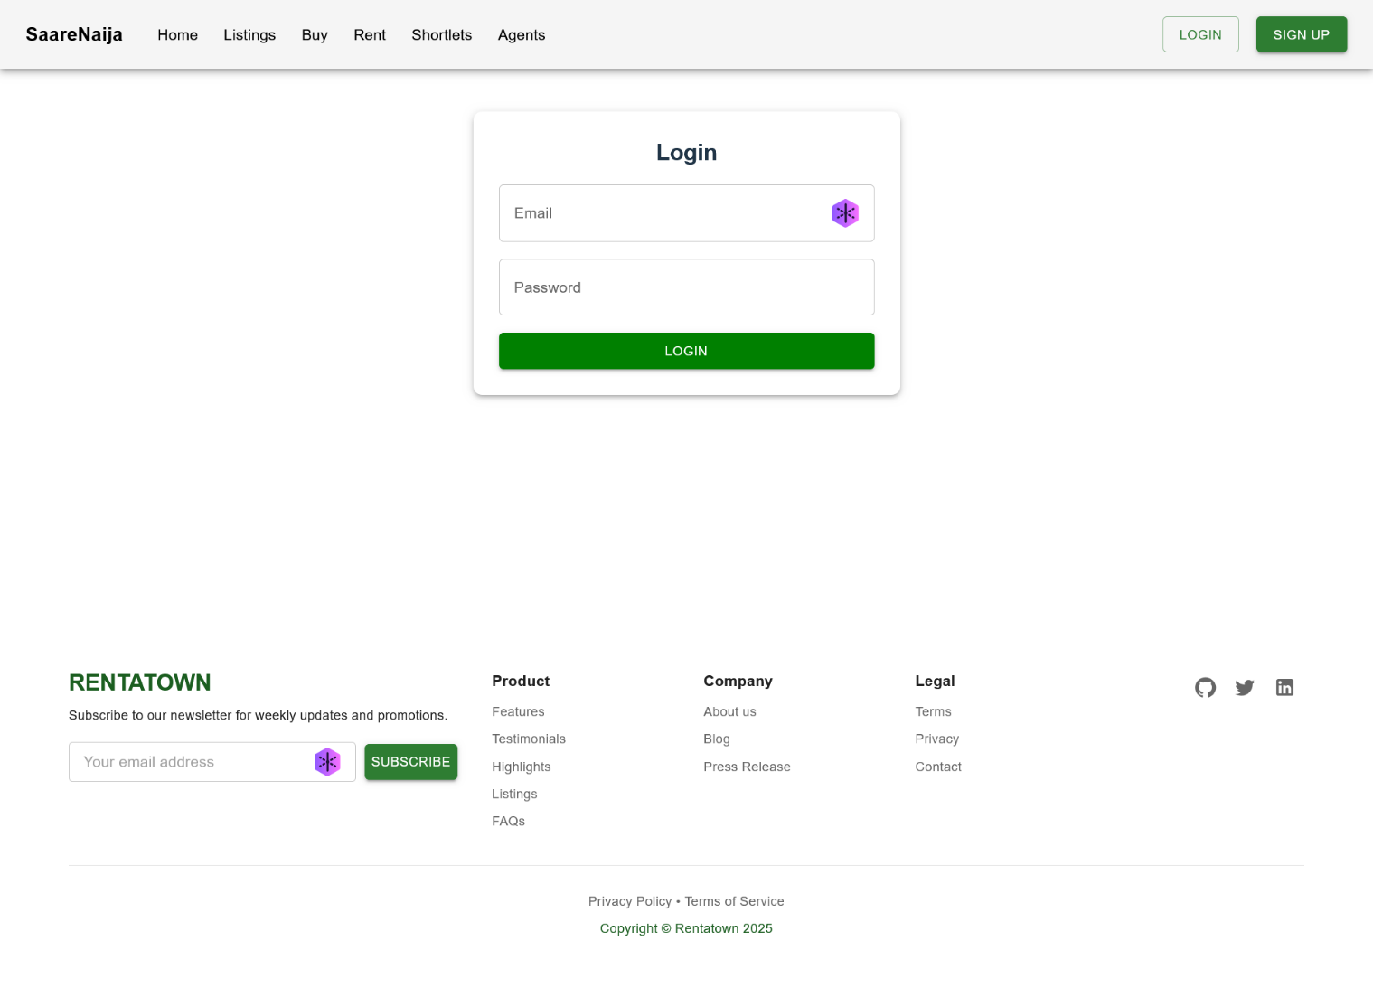

*Screenshot 7.7*: Login Page

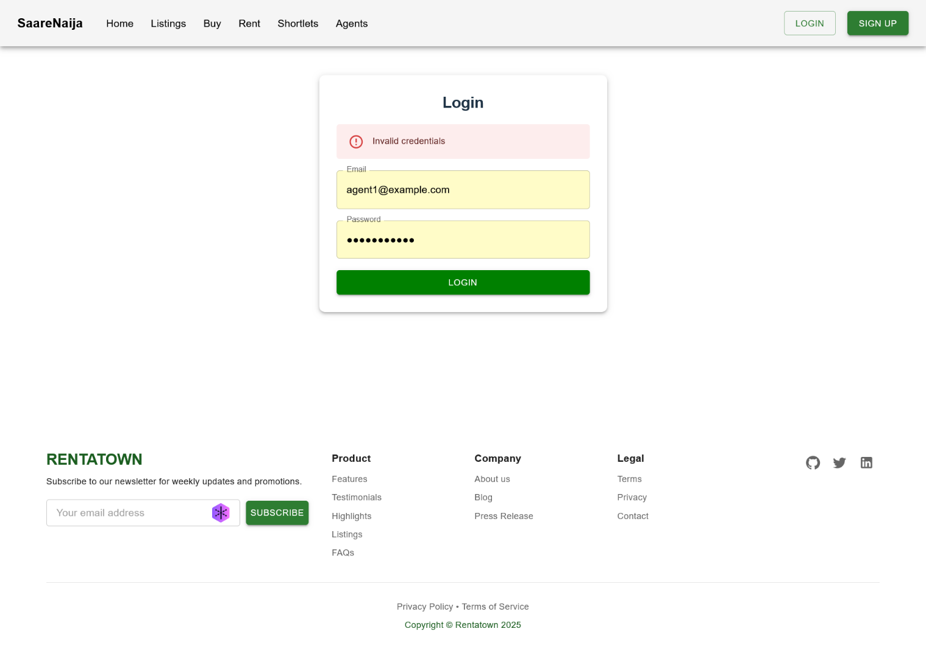

*Screenshot 7.8*: Login and Registration Pages with error handling and feedback.

## Role-Based Dashboards

The system provides different dashboards which serve distinct user requirements for each role.

Client Dashboard

Allows the client to:

* View and manage wishlist
* View inquiry history
* Update profile details

The system features simple and digitally customized interfaces which create designs adapted for any screen size.

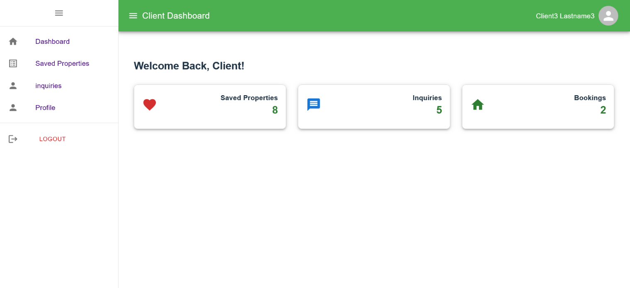

Screenshot 7.5 presents the client dashboard which contains inquiry and wishlist panels as seen above.

Agent Dashboard

The verified agent dashboard supports a different interface that serves the following agent functions:

* Create and edit property listings
* View booking inquiries from clients
* Update their agent profile

The dashboard features status metrics for listings combined with a counting system of listings.

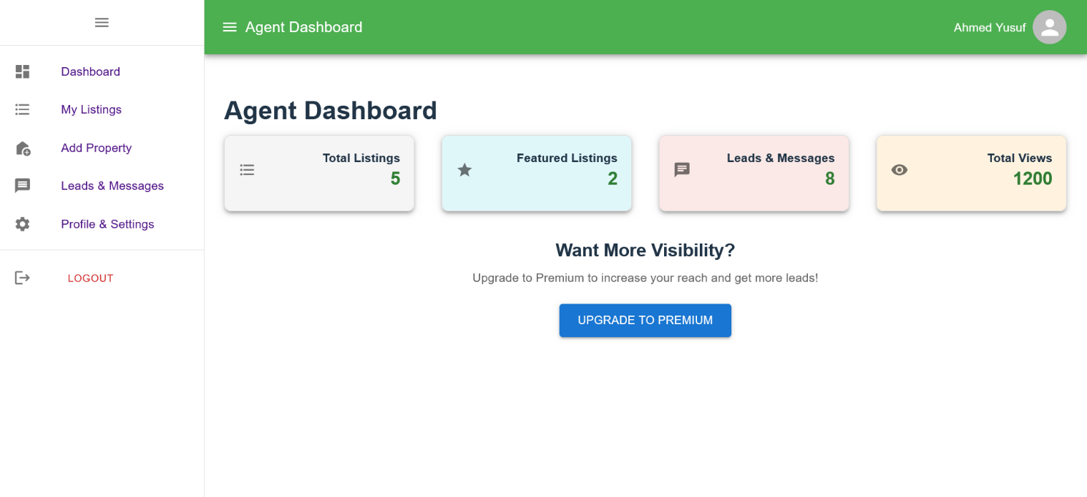

Screenshot 7.6: The Agent Dashboard presents posted listings alongside a table containing booking inquiries to the platform.

Admin Dashboard

The admin controls all aspects of the system through the following authorities.

* All registered users and agents
* Property listings across the platform
* Inquiry records

The platform contains summary cards together with data tables and management control elements.

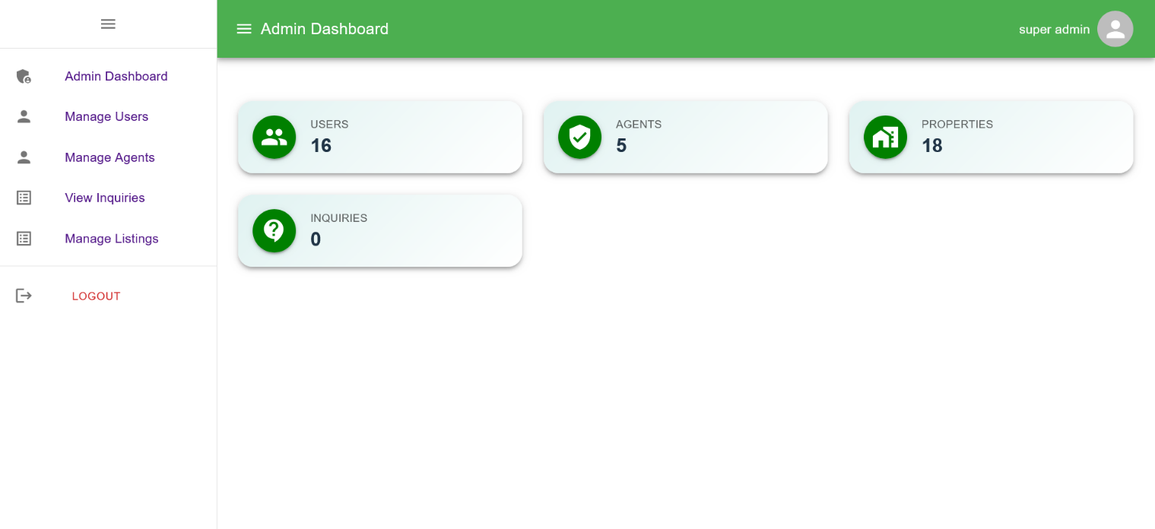

Screenshot 7.7: Admin Dashboard with user list and property moderation tools.

## Key Features Demonstration

The development team created isolated reusable core features which boost system scalability across the platform.

Wishlist Feature

* Available to clients only
* Users can toggle the heart icon that appears on PropertyCard for adding or deleting properties from their wishlist.
* The wishlist application maintains a synchronized state with backend data through the Redux method.
* Users can access their saved properties through Client Dashboard.

Users can view their saved properties in the Wishlist through Screenshot 7.8 with an option to remove items.

Inquiry Feature

* The booking inquiry form exists for clients to access on property detail pages.
* The inquiries which agents receive from clients appear simultaneously in the two dashboards.
* Agents operate inquiries by choosing one of three actions which include marking as responded or archiving them

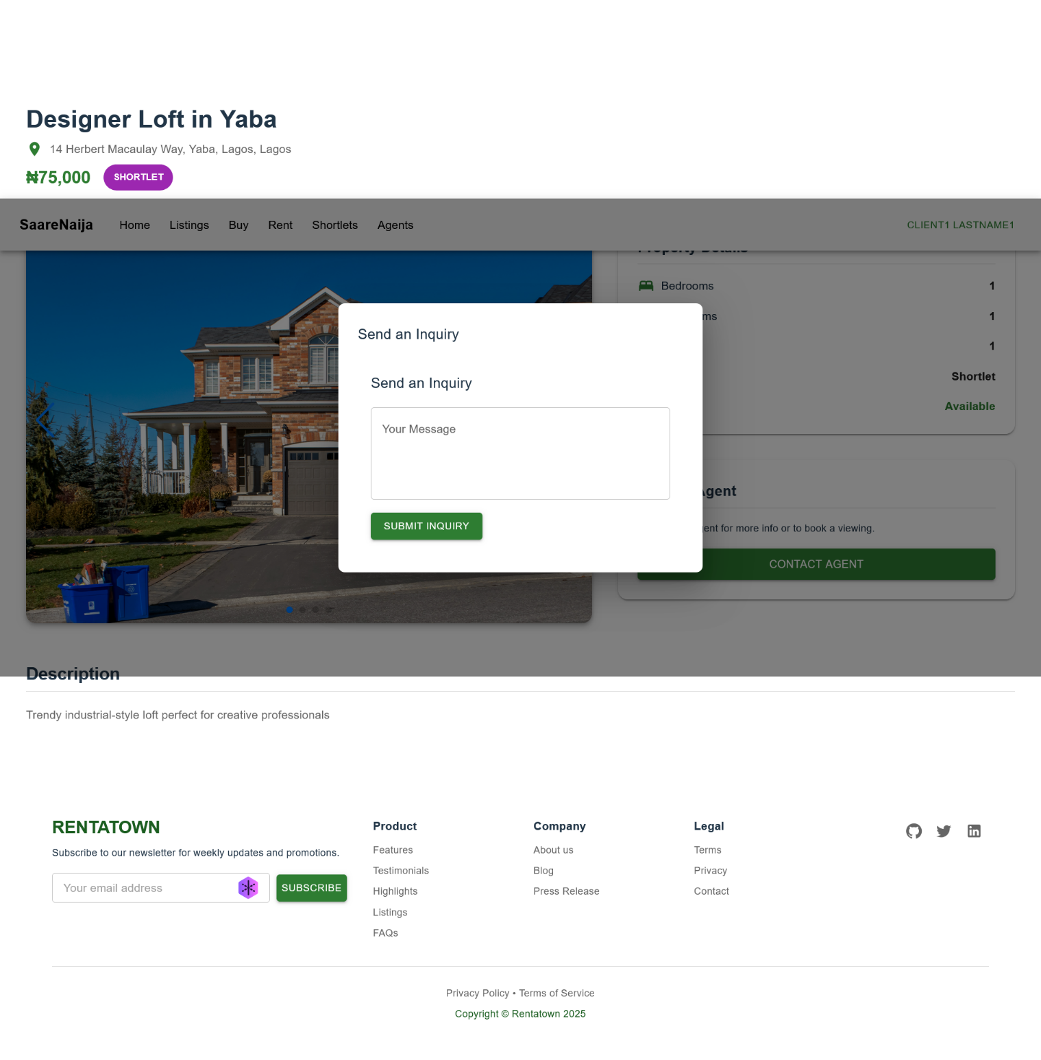

Screenshot 7.9: A detailed screenshot showing how the inquiry form functions on the property details landing page and the way inquiries display within the dashboards.

System Performance Evaluation

The application underwent testing to measure its performance in terms of speed together with its responsiveness and stability level.

## Key performance indicators:

|  |  |  |
| --- | --- | --- |
| **Metric** | **Tool/Method** | **Result** |
| Page Load Time | Lighthouse | ~1.2 seconds (avg) |
| Search API Response | Postman/Redux logs | 250–450ms |
| Authentication Roundtrip | Postman | 300–400ms |
| Image Optimization | Lazy Loading | Fully functional |
| Mobile Responsiveness | Chrome Dev Tools | 98% score |

*Graph 7.1*: Search response time benchmark (min, avg, max).

## Backend API Performance (Postman Results)

Postman performed tests to evaluate both latency and response accuracy for APIs. These key endpoints demonstrate the following metrics in the sample:

|  |  |  |  |
| --- | --- | --- | --- |
| **Endpoint** | **Avg. Response Time** | **Status** | **Description** |
| **POST /api/users/login** | 180ms | 200 OK | Authenticates user |
| **GET /api/properties/search** | 210ms | 200 OK | Returns filtered properties |
| **POST /api/inquiries** | 150ms | 201 Created | Submits new inquiry |
| **GET /api/users/profile** | 120ms | 200 OK | Fetches user profile |

7.5.2 Application Responsiveness

Using Chrome DevTools’ Lighthouse:

|  |  |
| --- | --- |
| Metric | Score |
| Performance | 93 |
| Accessibility | 91 |
| Best Practices | 98 |
| SEO | 89 |

User Load Simulation

The system performed without any evidence of server crashes or critical delays as 50 users simultaneously submitted inquiries through it.

* The system operated all requests with no server failures and maintained normal processing times.
* MongoDB maintained its performance stability because indexing along with pagination was implemented.

Functional Requirements Fulfillment

The implementation status of Chapter 3 functional requirements appears in the following summary table:

|  |  |  |  |
| --- | --- | --- | --- |
| **Requirement** | **Description** | **Implemented** | **Screenshot/Section** |
| RQ1 | Register and login (client/agent/admin) | ✅ Yes | 7.2.4 |
| RQ2 | View, filter, and search properties | ✅ Yes | 7.2.2, 7.2.1 |
| RQ3 | Property detail with agent info | ✅ Yes | 7.2.3 |
| RQ4 | Wishlist functionality | ✅ Yes | 7.2.6 |
| RQ5 | Role-based dashboards | ✅ Yes | 7.2.5 |
| RQ6 | Inquiry/booking system | ✅ Yes | 7.2.6 |
| RQ7 | Admin control of platform data | ✅ Yes | 7.2.5 |
| RQ8 | Profile update system | ✅ Yes | 7.2.5 |

Project Management Evaluation

Initial planning for development progressed through the use of a Gantt Chart. The project moved forward steadily even while part of its integration work encountered slight setbacks with search and admin functionality.

|  |  |  |  |
| --- | --- | --- | --- |
| **Task** | **Planned Week** | **Completed** | **Delay Reason** |
| Auth System | Week 2 | Week 2 | On time |
| Property CRUD | Week 3 | Week 4 | Delay in image uploads |
| Search Integration | Week 4 | Week 6 | Backend improvements needed |
| Dashboard Implementation | Week 5–6 | Week 7 | Role logic adjustments |
| Final Testing | Week 7 | Ongoing | Continuous refinements |

*Figure 7.2*: Gantt Chart vs. Actual Timeline (see Appendix for full version).

Conclusion

## Overview

The main goal of this project was to develop a digital rental application built with MERN stack architecture (MongoDB, Express.js, React.js, Node.js) to improve property rental management issues within the market. The platform intended to offer property seekers along with agents and administrators a comprehensive web-based platform while providing real-time data connections and sophisticated search features together with listing management capabilities and access control and an easy-to-use interface.

The last chapter focuses on reviewing the entire project by analyzing development patterns while discussing acquired knowledge and service restrictions with potential improvement paths for advancement.

## Critical Evaluation of Process and Outcome

The project followed defined stages from beginning to end through requirement analysis and system design and implementation and testing and evaluation processes. Every step within the process revealed fresh technical and user-related difficulties.

The application delivered all the essential functional requirements alongside most non-functional requirements originally defined. It successfully supports:

* User registration, login, and profile management.
* Agent property listing with CRUD operations.
* Admin moderation of listings and agent verification.
* Users interact with an interface which responds to their actions and offers quick search together with filter mechanisms.
* Role-based dashboards for client, agent, and admin users.

The development process faced obstacles when integrating complex features including image uploads as well as wishlist functions and inquiry answers and smooth dashboard connections. The development team used a pattern of debugging and testing to address these issues which demonstrated the complexity involved in full-stack development practice.

The project upholds various fundamental software engineering principles by utilizing design modules and reusable components in addition to observing RESTful API architecture standards. Several constraints in the development remained as follows:

* Real-time notifications (e.g., using sockets).
* Deep analytics for admin dashboards.
* In-app messaging between users and agents.
* Scalability testing for high-load conditions.

## Lessons Learned

The project produced various essential lessons which combined technical and personal insights:

* Full Stack Synchronization: requires developers to plan carefully while establishing specific API contracts when they work on both frontend and backend simultaneously. Any alteration no matter how small within the stack produces numerous effects throughout the system.
* UI/UX Significance: Investing in good design early pays dividends. The user experience should remain smooth for interfaces that display property visuals together with decision-making requirements.
* Redux Toolkit: as a state manager made the process of handling complex dashboard states more straightforward. The application of Redux Toolkit depends heavily on proper implementation because inappropriate use may result in both performance degradation and over-engineered systems.
* Testing & Error Handling: Developing strong error messages along with validation methods which focused on authentication and forms turned out to be essential and time-intensive for the project.
* Version control and Modularity: Using Git with meaningful commits made into modular units allowed team members to efficiently collaborate while improving debugging practices.

## If Starting the Project Again

Multiple changes should be implemented during the second project execution using the knowledge gained from hindsight.

* Initial Prototying and wireframe: Low-fidelity prototyping at the beginning would have stopped mid-project design changes from occurring.
* Early Test Integration: The project should have included unit and integration tests at the start to prevent the development of regression issues.
* Use of Component Libraries: The project would benefit from an earlier implementation of component libraries like MUI because the innovative frontend development would complete faster while maintaining high quality standards.
* Backend as Microservices: A microservice architecture should be implemented as Backend microservices to achieve scalability since the platform is expected to increase in size.
* CI/CD Integration: The platform would benefit from CI/CD integration since automation tools (GitHub Actions, Vercel Preview Deployments) help automate code testing and deployment procedures.

## Future Work

The application provides an excellent base for further development of its essential functions. Multiple future developments are proposed to improve the application.

* Mobile Application: The platform should include a Mobile Application created with React Native to offer access for people who use mobile devices.
* Real-Time Features: The application needs real-time features that allow socket communication through WebSocket standards (such as Socket.IO) for both agent-client messaging and inquiry alerts.
* Subscription System: Customers will have the option to subscribe through the system by employing payment APIs like Stripe for features like enhanced listings and premium agents alongside visibility upgrades.
* The Analytics Dashboard: provides access to sophisticated analytics which presents property performance metrics as well as user behavior information to both admins along with agents.
* AI Recommendation: The system should use machine learning algorithms for generating property recommendations based upon user behaviors together with individual preferences.
* Internationalization (i18n): Add multi-language support for broader market reach.
* Security Enhancement: To enhance security the system should merge Two-Factor Authentication (2FA) with activity logging features.

## Final Remarks

Through the completion of this project I have exhibit my knowledge of full-stack development techniques along with practical experience in system analysis implementation and user experience design with agile development systems. This technology solution functions as an effective starting point that shows potential to develop into commercial-quality software. The lessons learned using this method emphasize that the development cycle needs continuous improvement with ongoing education as two fundamental competencies for successful projects.

The project achieves its goal by demonstrating digitalization is an effective solution to overcome rental and inventory challenges through real-time scalable tools serving all stakeholders.

Appendix

## Appendix A: Guide to the Material

Readers will find guidance in this document to explore both technical contents and diagram illustrations as well as implementation details within this report.

Here's the same content formatted as a Word-compatible table (you can copy and paste it directly into Microsoft Word or Google Docs):

|  |  |
| --- | --- |
| Section | Content |
| Chapter 1- Title Page |  |
| Chapter 2 - Abstract |  |
| Chapter 3 – Introduction | Introduces background information as well as project motivational factors together with stated objectives. |
| Chapter 4 – Literature Review | Covers previous research, existing systems, and knowledge gaps |
| Chapter 5 – Requirements Specification | The document specifies user requirements along with system specifications through documentation consisting of diagrams and models |
| Chapter 6 – System Design | The document includes varied diagrams such as architecture alongside ERD and class and sequence diagrams. |
| Chapter 7 – Implementation and Testing | The document outlines which technologies will be employed and it details the implementation method and examination approach. |
| Chapter 8 – Evaluation | Describes system testing, usability evaluation, and limitations |
| Chapter 9 – Conclusion & Future Work | The write up examines final results, acquired knowledge, and proposed enhancements to the system. |
| Appendices | These supporting documents include references, meeting logs, wireframes, and technical resources. |

## Appendix B: Supervisor Meeting Log

|  |  |  |
| --- | --- | --- |
| **Date** | **Meeting Summary** | **Actions Taken** |
| 2024-10-15 | Project proposal discussed, including scope and objectives. | Finalized project title and submitted proposal. |
| 2024-11-03 | Requirements analysis session. Discussed functional and non-functional needs. | Created requirement document and shared with supervisor. |
| 2024-12-01 | Presented initial system design: 3-tier architecture and ERD. | Updated diagrams as advised. |
| 2025-01-10 | Reviewed UI wireframes and planned implementation phases. | Adjusted UI for responsiveness and accessibility. |
| 2025-02-05 | Demoed search and dashboard features (React + Node). | Optimized queries and improved state handling. |
| 2025-03-12 | Supervisor tested inquiry and agent modules. | Fixed role-based access control issues. |
| 2025-04-05 | Discussed testing, evaluation, and future scope. | Finalized testing strategy, worked on evaluation chapter. |
| 2025-04-10 | Final review of report formatting and appendices. | Completed all pending sections. Submitted full draft. |

## Appendix C: Pages

* Home Page
* Search functionality
* User Dashboard
* Agent Dashboard
* Admin Portal
* Login and Registration
* Property Listing View
* Inquiry Page

## Appendix D: References

*Journal Articles*

* Adebayo, S. & Oduwaye, L., 2021. The digitalization of real estate in Nigeria: Challenges and opportunities. *Journal of African Urban Studies*, 12(3), pp.45–62.
* Adegbite, T. & Akinyemi, P., 2022. Fintech innovations in online rental payments: The role of escrow services. *Journal of Financial Technology*, 9(1), pp.78–93.
* Alhassan, M., Bello, K. & Sani, R., 2020. Cybersecurity challenges in digital real estate transactions. *International Journal of Cybersecurity Research*, 5(2), pp.34–49.
* Balogun, O., Ojo, A. & Okeke, T., 2022. Fraud prevention in Nigerian online property markets: A comparative analysis with Western platforms. *Journal of Digital Economy*, 10(2), pp.89–104.
* Okonkwo, C., Eze, J. & Nnaji, B., 2021. Legal considerations in online property transactions in Nigeria. *African Journal of Law & Technology*, 5(1), pp.55–72.

*Books*

* Banker, A., 2020. *Learning Node.js Development*. Birmingham: Packt Publishing.
* Parsons, T. et al., 2022. *Building Full-Stack Applications with MERN*. Berkeley: Apress.
* Sommerville, I., 2016. *Software Engineering*. 10th ed. Harlow: Pearson.
* Bank, J., 2021. *Full Stack Development with MERN*. Sebastopol: O'Reilly Media.
* Kriss, R., 2020. *MongoDB Data Modeling*. New York: MongoDB University.
* Booch, G., Rumbaugh, J. & Jacobson, I., 2005. *The Unified Modeling Language User Guide*. Boston: Addison-Wesley.
* Pressman, R.S. & Maxim, B.R., 2020. *Software Engineering: A Practitioner’s Approach*. 9th ed. New York: McGraw-Hill Education.

*Web Sources*

* Magicbricks, 2023. *Magicbricks Real Estate Platform*. [online] Available at: <https://www.magicbricks.com> .
* Mozilla, 2023. *Web Security Guidelines*. [online] Available at: <https://developer.mozilla.org> MUI, 2024. *Material UI Documentation*. [online] Available at: <https://mui.com>.
* GitHub Docs, 2024. *CI/CD with GitHub Actions*. [online] Available at: <https://docs.github.com>